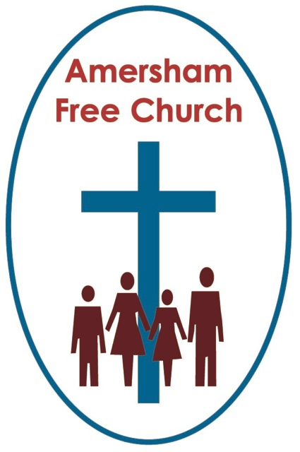
Sunday 4th January 2015
John 1.10-18

What might it mean to say: The Word Became Flesh?
Gracious God, we thank you for your word in scripture and made flesh in the Lord Jesus Christ. Help us now to catch your voice and speak, we pray, to our hearts and minds. In Jesus’ name. Amen.
Up and down the country last month carol services will have reached their climax with a reading from John 1. It’s not an easy reading – partly because it uses the Greek idea of Logos – or Word – to describe an aspect of God. Of course what makes it a favourite to be slotted in between O Come all Ye Faithful and Hark the Herald is the poetry of John which talks of The Word Made Flesh.
This very idea that God would so identify with his world that he would come and live, as it were, among us was a step too far for most Romans and Greeks. Their appreciation of the divine was of a more distant force within the universe – Gods with names like Poseidon, Jupiter, Vulcan or Minerva brooded over the earth and needed to be appeased.
So the idea of The Word made Flesh brought a different understanding to faith because it seriously challenged a traditional definition of who God is and how he behaves.
I remember years ago in Hitchin cutting the front lawn on a summer’s day and one of our deacons pulled up outside the manse in his car. He seemed tickled pink to see his minister in scruffy clothes pushing the mower and shouted his greeting at me that went something like ‘Great to see you are just like the rest of us!’
This struck me as a bit odd at the time! Who did he think would be cutting the grass? But it obviously both amused and reassured him to see his minister doing something ‘normal’!
‘Just like the rest of us’ – OK it’s not as poetic as ‘The Word made Flesh’ but it begins to unpack the idea that in some mysterious way, through Jesus, God shared our life in such an intimate way that every part of it is somehow hallowed by the incarnation.
I was thinking about this passage from John, so familiar to us at the turn of the year as I looked at the Madonna and Child paintings in the Central Hall of the National Gallery on New Year’s Eve. It’s a great collection and the first thing you see at the top of the entrance staircase. The paintings, many from Italy, are exquisite, yet I confess I’m not entirely convinced by the message behind them. Without exception they presented a serene mother looking into the middle distance with an adult looking child on her lap, often surrounded by adoring onlookers. All very ethereal, even majestic but, I suspect, just about as far away from the real experience of Bethlehem or Nazareth as it is possible to get.
Do these beautiful paintings really encapsulate the phrase ‘Word made Flesh’?
For me, on New Year’s Eve, it rather reminded me of that verse which has been omitted from our blue hymn books and makes Away in a Manger a rather short sing. The verse that says ‘The little Lord Jesus no crying he makes’.
I remember stumbling over that line the Christmas after I became a father – in fact I remember I simply couldn’t sing the words without a smile of incredulity!
The Word became flesh and dwelt among us – what does that mean?

If we understand it as a commentary on the life of Jesus then it means he upset his parents rather thoughtlessly by staying behind at the Temple in conversation with the elders. It means he speaks with a certain harshness to his mother at the Wedding Feast in Cana of Galilee. It means his siblings, who must have known him well, took a great deal of convincing that their brother was anything but mad as he embarked on a three year preaching tour.

This idea of Word made Flesh isn’t serenely passive and ethereal but about living in the cut and thrust of family life, pushing boundaries, experiencing and even fuelling rivalry and jealousy and perhaps even misreading the needs of others.
The tradition in which I grew up was, I think, rather quick to say all that kind of behaviour comes about because we live in a fallen world. The irony is, surely, that this is just about all we know of Jesus growing up in those missing years within the gospel narrative.
But what if these experiences are simply viewed as part of what it means to be human – to push boundaries, to make mistakes, to evolve in our appreciation of family ties, to grow into a mature way of thinking and to keep growing and growing.
If that’s our understanding of life – the life we lead and the one Jesus shared then of course it calls into question the idea of the Little Lord Jesus – no crying he makes.
Perhaps a better title for today’s sermon might have been: What kind of teenager was Jesus?’ I’d like to answer – ‘a normal one’!
But back to New Year’s Eve at the National Gallery because the more I thought about it the more I realised that maybe an essential aspect of nativity had been overlooked by these renaissance artists – something so implicit in any relationship between a Madonna and Child – that of vulnerability.

You get a very different picture if you walk across Trafalgar Square and stand in the porch of St Martin in the Fields where there is a sculpture of the infant emerging, as it were, from a block of marble – naked, as if about to cry, the umbilical cord still attached – vulnerable.
God among us not in serene glory but as a dependant new born. God, entrusting himself to us!
I suspect we humans have often tried to use our religions to boost our egos and confirm our ambition for power. But that isn’t, I think, at all the meaning of Christmas.
God, in Jesus, shares our vulnerability. Yet where was the painting of a crying, demanding, hungry, sleep depriving Christ-child in the National Gallery’s collection. Too soon we made him into a ficticious and maybe even grotesque icon of perfection – and in doing so missed the point.
Because the point is that all of us are vulnerable too.
We need each other. We needed our parents and teachers. We need our family and friends. We will need our doctors and care workers. We needed to have our hand held when we were young and pray God someone will be holding it as we breathe our final breath.
Yet to be vulnerable is not to fail – it is to be human – to live the sort of human life lived by Jesus – vulnerable in a Bethlehem manger and vulnerable upon a Jerusalem cross.
And that in many ways ties in with this other significant phrase we have been given in John 1 calling us ‘Children of God’.
There are quite a few collective nouns given to us in scripture: believers, disciples, Christians and here’s another Children – children of God.
And what, I wonder, does such a description say to us, or describe about us on this the first Sunday of 2015?
When my parents died, rather quickly one after the other, someone in my then congregation – trying to be helpful – said to me over the after service coffee: ‘Well you’re an orphan now Ian’. Well, even though I almost chocked on the digestive biscuit I’ve often reflected on his words because actually there is a ring of truth and even wisdom in what he said. A feeling of being alone. Grateful for the past and especially grateful for continuing family and friends but, yes, with both parents gone a certain sense of being alone.
We sometimes talk of our relationship with God in these parent relationship terms. In the Lord’s Prayer we even use the term ‘Our Father’.
Sometimes we are little children of God – sensing a deep dependence upon him for protection and meaning.
Sometimes we are teenage children of God – testing the relationship, pushing the boundaries and growing by asking those awkward questions and even rebelling on the way.
Sometimes we are older children – we appreciate afresh the wisdom of God and recognise that so much of our identity stems from his character of love and justice.
And often we are all these children mixed up as one. For in ourselves we are both the Prodigal and the Elder Son at one and the same time.
But we are not alone – surely that is a beautiful consequence of our understanding of being a Child of God – we are not alone.
Over these Christmas Days and into New Year we have visited relatives and had them to stay and sometimes we have gone for a walk together. Younger ones marching off in front, older ones taking up the rear. At times senior members of the family have urged me to walk on with the younger members of the tribe – but more than once I decided to stay at the back and go at their pace – because, in a sense, nothing is more special than walking at the pace of the slowest.
As a Child of God I’d like to think God walked with us when we were young and carefree full of exploration and running to discover. In our teenage years he continued to walk with us when we were angry, defiant, self sufficient yet secretly still yearning to be loved and cared for. And in our older years he walks beside us even as our pace slows down.
In 2015 – as Children of God - we trust in the God who walks beside us.

We are not alone – it’s the message of the season:
God with us and
God among us.

And all of that can surely make for a Happy New Year.
May it be so in the name of the Father, Son and Holy Spirit. Amen.
Ian Green, Amersham, New Year’s Day 2015

