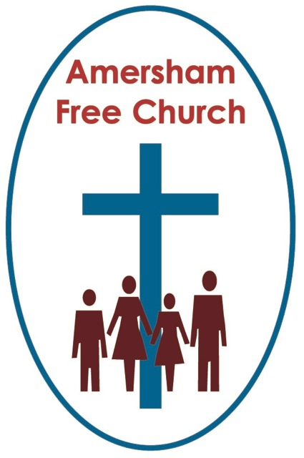
Matthew 2.13-23

The Dark Side of Christmas
Gracious God, we thank you for your word in scripture and made flesh in the Lord Jesus Christ. Help us now to catch your voice and speak, we pray, to our hearts and minds. In Jesus’ name. Amen.
I’m sure, despite the TV adverts and occasional sentimental film, none of us actually had a perfect Christmas. The potential for a culinary mishap, a family misunderstanding or simply a burst tyre must have been quite high over the last few days. In fact there can be a quiet sense of relief simply to have made it to this Sunday – the one after Christmas!
During my College days I remember returning home to Southampton one Christmas Eve, the house was full of relatives staying over, but as I went in they all looked very glum and very cold. That afternoon the heating had broken down. Managing to get a plumber that evening had been difficult – Dad said they seemed to be busier on December 24th than Father Christmas.

Well this morning I just want to reflect on three moments when the first Christmas seemed to get derailed. Here they are:
The Magi looked in the wrong place
King Herod killed the wrong children
And the Holy Family returned to the wrong home.

So we start with those Wise Men, their problem – well they were looking in the wrong place for Jesus.

They went to Herod’s palace – an obvious place to start, but in fact the wrong place to look.

Apparently it’s very difficult to define the word Magi – almost certainly this group of people were from Persia. They were respected as academics, philosophers – so they were thoughtful people who pondered life and its meaning. And part of being educated in those far off days is that you became rather good at stargazing. The patterns in the night sky gave pointers about the universe.

Herod asks the wise men when exactly they saw the star – and presumably it’s on the basis of this information that he kills all baby boys in Bethlehem two years and under.

So maybe the journey of the Magi had been a long one – they had been searching for two years – and when they came to Herod’s palace in Jerusalem they finally thought they were in the right place. But it was the wrong place.

Suppressing his anger, publicly at least, Herod calls for his own wise men, royal astrologers and court academics get out the scrolls and read from Micah 5.2 which speaks of Bethlehem as the Messiah’s birthplace.
The image or concept of looking for Jesus is an intriguing one – and so often, like the Wise Men, we discover him in unexpected places.
This Christmas I’ve been struck once again by the mystery at the heart of the narrative. To watch a nativity play or sing a familiar carol is sometimes to let the inherent contradictions of the story actually wash over us. There is nothing simple about the idea of Incarnation.
So although we Christians believe God has revealed himself to us in the person of the Lord Jesus Christ we recognise once more at this festival that his birth was muddled in misunderstanding.

Our Regional Minister, Geoff Colmer signed off his Christmas letter this year with a lovely Christmas prayer from Iona that sums this us:
When the world was dark
and the city was quiet,
You came.
You crept in beside us.
And no-one knew
Only the few
Who dared to believe
That God might do something different.
I wonder, like the Wise Men, where we expect to encounter God’s presence amongst us? We may meet God in church – but never exclusively so. We may meet God in our traditions – but never inevitably so. We may meet God in the bible but never simplistically so.
As one prayer puts it we seek the revelation of God through ways known and yet to be made known.
The Wise Men learnt it at Christmas, God is often encountered in unexpected places – yet it’s a lesson that’s relevant for every day of the year.
A second problem – and indeed a tragic one – Herod killed the wrong children – the tragedy within today’s lectionary reading.

This Herod is much worse than the one we meet in the Easter story. This Herod killed his wife, Marianne and three of his sons, Antipater, Alexander and Arisobulis. Do you know that the Emperor Caesar Augustus used to joke that it would be safer to be Herod’s pig than one of his sons? Herod was a tyrant king who could stand no rivals. But in his madness he killed the wrong children.

Herod knew that no one loved him. That’s why he ordered that on his death 70 of the most intelligent, artistic and creative men in Israel should be put to death. The absurd reason for such a decree? He wanted people to shed tears at the time of his death, he knew they would never do that for him, but at least people would weep when they heard of these 70 innocent artists and thinkers now gone to an early grave.

There is a Chinese Proverb, which could well apply to Herod the Great, it goes like this: Who is narrow of vision cannot be big of heart.

So Herod kills the wrong children – in his deep insecurity and mistrust of the people he orders the death of these Bethlehem boys. The town was a small one and maybe no more than around thirty were slain – of course that was thirty too many.

This is the dark side of Christmas – yet it’s life as we know it. Still today the wrong people suffer.
Just before Christmas it struck me as a cruel irony that in the very week the world celebrated Malala being awarded the Noble Peace Prize for all she did in standing up for education in Pakistan the Taliban launched an horrific assault on a military school in that country killing over a hundred innocent students.
Blend a fundamentalist take on any faith or dogma with an insure longing for political power and history charts a tragic and predictable course from the Slaughter of the Innocents to the Crusades and The Holocaust to this month’s Pershawer school attack.
On the one hand we lament ‘Man’s inhumanity to Man’ and cry ‘Lord have mercy’ and on the other we need to think deeply about what it means in the Sermon on the Mount for us to live as ‘Peacemakers’ in our fractured world.

Herod was a king who stood for nothing but himself
Jesus is a king who, in love, gave everything, even himself.

The wise men went to the wrong place, Herod killed the wrong children and finally in our Christmas derailed trilogy: The Holy Family return to the wrong home.

After receiving Sat Nav directions from a heavenly source Mary and Joseph take Jesus to the safety of Egypt as they, in essence, become asylum seekers.

But then they weren’t the only ones. The Jewish population of Alexandria in Egypt at that time was estimated at a million; indeed every Egyptian town had a Jewish quarter.

Eventually they returned home. On Herod’s death the family rearranges itself with one son in southern Judea and another in northern Galilee succeeding him. The southern son was a chip off the old block so setting up home back in Bethlehem was out. Instead they ‘withdrew’ to Galilee and Nazareth with its more lenient ruler.

So at the beginning of their marriage and family life they had already been scandalised by the gossip surrounding a quick marriage and traumatised by the experience of their refugee status.
As we leave the Christmas story this weekend I think that the sense of mystery behind it has, for me this year, actually grown. I’ve come to the conclusion that its themes are so deep that maybe the only appropriate response is kneeling rather than explaining.
In the narrative it all seems to happen at the margins of society and through the most unusual of people.
For us Christmas can become rather predictable, comfortable and reassuring. How odd then that for its original participants it was so thoroughly unexpected, uncomfortable and disturbing.
And yet, and yet....we celebrate the timeless truth that Christmas brings to us year after year that even though life is never perfect, that our plans get derailed and our aspiration thwarted, still God is with us and among us. For as the angel says to Mary at the start of this story: The Lord is with you. And when we believe that – when we believe in a God called Immanuel it makes all the difference.

In the name of The Father, Son and Holy Spirit. Amen
Ian Green Amersham 27th December 2014

