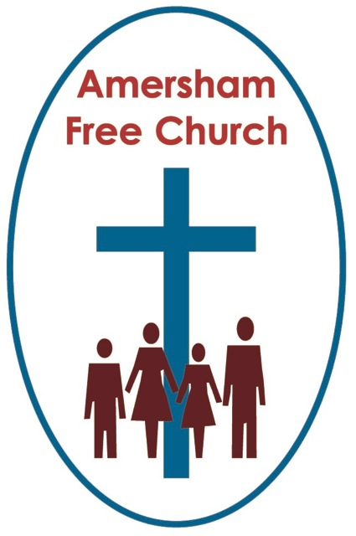
14th December 2014
Psalm 126
Luke 1.26-38

Annunciation

Lord God – our prayer is that the written word will point us to Christ, the Living Word – so in his name we pray and for his voice we listen. Amen.
And now, as they say, for something completely different – at least from me.

Today’s sermon on the theme of Mary is in the form of a monologue – so here goes!

My name is Aaron and Nazareth has always been home. Every Saturday I went to Synagogue and there met my best friend Joseph. We basically grew up together and although I never shared his love for carpentry throughout our youth we ran through the olive groves and met up at the well most days.
And then he came across Mary – this girl from our part of town. It was a quiet courtship – they were quiet people really – we were the sort who blended in and never made a fuss. But all of that soon changed.
This is how he told me it unfolded.
They had been making plans and everyone seemed pleased it was going the way it was. But then Mary came to him one day and said God, no I think he said an angel – called Gabriel had visited her the night before and there had been talking, and questions and none of it really made any sense and she was worried that he would think her one of those zealot types, full of religious fervour and illogical mysticism.

But the point is this, everything changed because of that ‘encounter’. Everything was interrupted – their quiet, predictable, background sort of life – totally interrupted. Does God do that do you think?
Joseph told me Mary was scarred by what she thought she’d received from God that night. There was talk of her being favoured yet it seemed a terrifying honouring. And I reckon people will never get to the bottom of it – Virgin Birth, God made man, Magnificat – enough there to keep theologians in work for perhaps two millennia!
And then they both vanished overnight. I don’t blame them really because things were getting pretty heavy in Nazareth. There was gossip and misunderstanding – people now just talked of Mary differently with nods and winks. I spent hours with Joseph just listening to his dilemma. At one point he’d had enough and wanted to break it off but then he too seemed to get some divine reassurance and pressed on.
I guess you know how the story ended – but we didn’t. I think you call it Christmas and it all sounds quite sweet – but to my friend Joseph these were just tough days with loads of hanging on in there. Perhaps that’s a more honest definition of faith than all the talk I sometimes hear about certainties and absolutes. Mary and Joseph made that journey from our town to Bethlehem for that ridiculous and intrusive census (forgive me but I’m not a big fan of our Roman occupying army) – but it was never just about a physical journey – theirs was a difficult road to travel with one timid and unsure step at a time.
They came back eventually – after about a year or two – you might even be forgiven for thinking their son, Jesus, spoke his first words with a slight Egyptian accent. Don’t know what was going on there.
They had other children and actually things settled down a bit and I started to wonder what all that fuss around their engagement time was about. They had a near miss once returning from Jerusalem when they seemed to loose Jesus – the Synagogue Child Protection Officer was just about to lodge an official complaint but then Jesus turned up and the whole crisis evaporated.
I was devastated when Joseph died so young. I never thought he got enough credit in that family. Everyone seems to talk about Mary and Jesus with Joseph airbrushed out. Seems a shame to me because I saw the hours he spent talking to Jesus,
Then Mary seemed to loose Jesus a second time – but this wasn’t hushed up. He left the family and became one of those wandering, itinerant rabbis. We honour them in our tradition. They are penniless and go from place to place teaching and preaching. I think most people in Nazareth were pleased that one of our own showed so much faith and love for our Jewish traditions. Well that was until he came back to preach at Synagogue. I think he overstepped the mark that Saturday – he made great claims for himself and I don’t know, it just didn’t go down well. I’m not sure we all became the lynch mob others claim, but it is true that Jesus left town quickly without the usual preaching cheque!
I find, and I can’t quite put my finger on it, that Mary knew something extra about all of this. In some ways it was all so ordinary. She had a growing, at times dysfunctional family – and what’s new about that? But she also possessed a deep sense of conviction that kept her going. She seemed just to be loyal and devoted to her son. Is that what love is, is that what faith is – something so ordinary that you find it in families and relationships and yet, and yet it changes everything, framing life and giving meaning to the everyday.
Mary and Joseph’s boy seemed to be breaking new ground. I have friends in Caperneum on the shores of Galilee and they told me Jesus made base camp there and did well with a recruiting drive amongst fishermen.
My tradition loves the image of a Messiah. We spend hours trying to work out what we mean by that – and it seems over the next few years Jesus, who went to the same Sabbath School as my own boy, more and more people talked of him in this Messianic way.
But he shocked me if what I heard was true. He honoured our laws and traditions but deepened them talking about forgiving seventy times seven, looking at the heart and motivation not just our rituals.
I lost touch with Mary for a little bit. Word got back to us that Jesus wasn’t tolerated down south – I couldn’t work out whether the Temple or the Palace was to blame but I was sad to hear of the crucifixion. Yet I believe she was there, at the end she was there – at the cross she was there – and I guess when you’ve said that you’ve said it all.
I have a suspicion that my friend, Joseph’s wife, has been – how shall I put it – quite contentious in your history – or should I say church. Is church the same as synagogue or would it be more like temple? Actually that’s a red herring and not at all the point of this monologue!
I’m told a group called the Catholics have honoured her – but I was a little surprised to see that their priesthood seems to stay resolutely male. That Protestants (I must say I find that a odd term, to describe yourselves negatively as protesting against an interpretation of faith - but once again I digress) that Protestants don’t really know how she fits in and confine her to the annual nativity play.
Mary eventually came home to us. An air of sadness never really left her – but does it ever to a parent who loses a child.
I think Joseph would have been proud of her though.
For me she actually became something of a role model. I know my life hasn’t been as dramatic as hers and perhaps I’m really grateful that my family just looks very ordinary alongside hers.

But that’s the point I think. If all those dreams and visions that my school friends Mary and Joseph had all these years ago were true, if Jesus – the boy from our neighbourhood did in some mysterious way show us God in human form, if his radical message and his embodiment of love can sustain a faith tradition in the future – then Mary’s story inspires me.
I’m inspired by her trust in God. That she seemed to glimpse possibilities where the rest of us just saw problems. That in the struggle to cradle, nurture and then release the gift she believed God had given her, the gift of her son, she went through that whole raft of emotions common to us all who ever experience love – the love of family, friends, relationship and community.
Of course Mary never left any writings or pithy sayings, I wonder if that’s why John never mentions her by name and Paul simply never mentions her. I don’t think doctrine was her thing. Instead she just got on with the practice of faith, living it – the ups and downs, letting it develop. And the struggle and the confusion and the dubious reputation – none of that invalidates her journey, the road she made and walked through life. More than anyone else I know she seemed to hold on to the belief that God is always and everywhere present in our lives. That he seems to touch our lives with his life of love and light, goodness and hope.
When we had a daughter perhaps you won’t be surprised that we called her Mary.
Mary, Joseph – two of my best friends who taught me so much about life and faith.
Oh, and by the way – blue was never her favourite colour!”
Ian Green – Amersham – 12th December 2014

