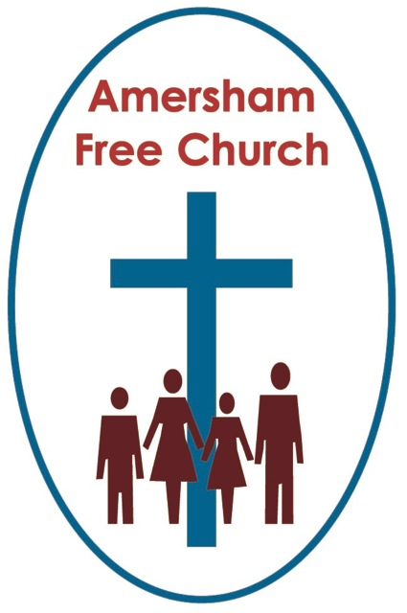

Psalm 23 p.463
John 11.17-44 p.90
2nd November 2014 All Saints Sunday
Grief, Hope and Peace
Many services, like ours this morning will be reflecting on themes such as grief, hope and peace, because we are at that point in the church calendar we call All Souls and All Saints tide. Indeed some hospices and churches have taken to holding commemoration services around now when bereaved folk are invited to church to light and candle and hear the name of their loved one remembered.
So, on this All saints Sunday what does our faith have to say about grief, hope and peace, for surely all of us experience grief, long for hope and pray for peace.
Grief. We seem to have extremes in our society. Either it’s a private emotion to be coped with behind closed doors – or it sweeps through a community as in the case of the untimely passing of Princess Diana. And recently there has been much in the media about the death of Linda Bellingham and the courage she showed as it approached.
In New Testament times a whole village shared the grief of a family bereavement. Family and friends were encouraged to weep openly and together on the day of the funeral – this was a shared pain. Afterwards the family retired to their home where they stayed for 7 days – mourning together, telling stories, giving themselves time before embarking once more in the daily routine.
I recall the death of another well known TV personality who was also a fine Christian. The newspapers, perhaps out of context, published his wife’s reaction to his death – no tears, she said, should be shed for her husband. I’m sure she wasn’t being cold, she obviously loved him very much, and I’m also sure she was trying to express her Christian faith that someone she loved was now with God. But...it isn’t wrong to cry – it’s good to cry – it’s helpful – we might even say it’s Christlike.
In this morning’s reading we are given one of the bible’s most precious verses: Jesus wept. In Sunday School I learnt it was the shortest verse in the New Testament. But as I’ve got older I’ve begun to realise it’s one of the most important verses in the whole of scripture.
Jesus Christ – who reveals to us this Christ-like God – weeps at the untimely death of a good friend. So two words – Jesus wept – show us the compassion and tenderness of the God we worship. A God who shares our pain and carries our sorrows – who is never nearer to us than in those hollow moments when we feel so empty because someone we love is no longer here.
After 9/11 the British Community in New York held a memorial service at which the Foreign Secretary read out a message from the Queen. She is sometimes thought of as being a little formal in her words, but not this time. Perhaps writing not so much as monarch but as a daughter who lost her father when he was just 56 she wrote: Grief is the price you pay for love.
All of us experience grief, long for hope and pray for peace.
Hope. Yes – at the centre of Christianity there is a death and a resurrection. A cross and an empty tomb.
It’s difficult for us in a liberal democracy to fully appreciate the early days of the church when Christians often suffered martyrdom for their faith. St Paul was probably beheaded because he preached the gospel of Christ. Whilst writing to the Philippians from prison he ponders his future. It was in the balance – but he concludes: For me to live is Christ, to die is gain.

We may, quite naturally, fear death. Most of us would do all that is possible to stay alive. However, when the time comes, may we be given the grace to believe that death is not a full stop.
I think, when pondering death, I take the greatest inspiration from the words of the Lord Jesus upon the cross as he says to the penitent thief, dying beside him: Today you will be with me in paradise. If I wanted just one bible text telling me that death is not the end it would be that one. Today you will be with me in paradise.
That’s the Christian hope we proclaim every Sunday – the day of resurrection.
It’s funny what you learn at college – some of the greatest lessons are not in the classroom and I remember once one of my tutors returning after a funeral service grumbling. We were intrigued at what had irritated him so much. Over lunch he told us – never once, he said, at that morning’s funeral service in church – had the minister mentioned the resurrection.
Well he had a point. Our hope is in Jesus Christ – and all he did for us on Good Friday and Easter Sunday.
Early Christians symbolised this in always having their coffins buried facing east – towards the dawn of a new day – that was their hope, that death wasn’t the end but a new beginning, as much about sunrise as sunset.
We come experiencing grief, longing for hope and praying for peace.
Millions of words have been written about death, dying and bereavement. Yet death remains a mystery.
I’ve conducted just over two hundred funerals services and at every one I believe God has shared the pain of the bereaved – yet I know the depth of the struggle we all go through when bereaved.
CS Lewis is one of those authors brave enough to write about loss. In his book, A Grief Observed, he shares with us the extremes he went through when Joy, his wife, died of cancer.
The honesty of this book is truly helpful: he wrote: We can do nothing with suffering except to suffer it. Who still thinks there is some device which makes pain not to be pain?
Lewis said that: Sorrow turns out not to be a state but a process. It needs not a map but a history.
That history for him meant many turns in the road. Times when he felt he had found peace only to sense its absence a few days later. During that process he questioned both God and his faith.
Yet – in his journey – some resolution of his grief, some peace is experienced when he is able to write: Something quite unexpected has happened. It came this morning early. For various reasons, not in themselves at all mysterious, my heart was lighter than it had been for many weeks. And suddenly at the very moment when, so far, I mourned her least, I remembered her best.
Our prayer is that the peace of God, which passes human understanding, will keep our hearts and mind in the knowledge and love of God. A peace that doesn’t deny the depth of pain and loss we feel, yet a peace that enables us to believe the person we love is at rest in God’s nearer presence and a peace that gives us the ability to face the future with God and each other.
We come experiencing grief, longing for hope and praying for peace.
When my grandmother died almost five years ago I lost one of the most loving and influential people in my life. She was and is absolutely central to everything that makes me who I am today – I read this well know poem at her funeral – although it is not explicitly Christian I believe it captures implicitly the New Testament’s teaching about one of our greatest human needs, about bereavement:
You can shed tears that she is gone
or you can smile because she has lived.

You can close your eyes and pray that she’ll come back
or you can open your eyes and see all she’s left.

Your heart can be empty because you can’t see her
or you can be full of the love you shared.

You can turn your back on tomorrow and
live yesterday
or you can be happy for tomorrow because
of yesterday.

You can remember her and only that she’ s gone
or you can cherish her memory and let it live on.

You can cry and close your mind, be empty
and turn your back
or you can do what she’d want:
smile, open your eyes, love and go on.
May that be our prayer, our hope and our peace in the name of God the Father who shares our pain, God the Holy Spirit who gives us peace and God the Son who wept outside a beloved friend’s tomb. Amen.
Ian Green Amersham 23rd October 2014

