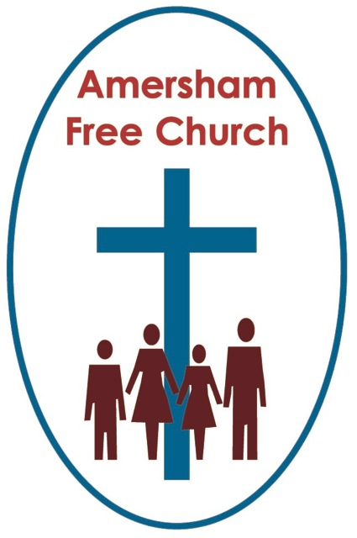
Psalm 80.7-15
Matthew 21.33-46
5th October 2014

The Stone Rejected...

Gracious God – we open the bible and long to receive your word – open, we pray, our minds and hearts to receive that word with all its comfort and in all its challenge. Amen.
This week at Lancaster House just off The Mall politicians, scientists, medics and ngo’s came together for the ‘Defeating Ebola’ conference. The message seems to be there is the smallest of windows, just a month to stop this deadly virus from becoming out of control in West Africa.

It was encouraging to see a greater understanding and co-operation emerge between these influential organisations. Yet the image that many will take away, I suspect, was that of a young man, himself an Ebola survivor and health worker William Pooley speaking about the impact of the virus even as we learned that last week he flew to the US to give blood so that scientists there could gain a greater understanding of why he made it through an illness that has proved so fatal to many others.

Pooley is a recent inspiring example of people who put themselves at risk, even physical risk, in the search for helping others. The age of sacrificial service, it seems, isn’t over.

And that is something of a theme that runs through this morning’s New Testament reading – a parable about the giving of a son and a parable that could have a number of different names.

It could be named as the story of the wicked tenants (and is often referred to as such), or maybe you think it ought to be termed the parable of the reckless owner – the owner who not only seems to be away too much but then sent his son to collect in the debt.
Yet I would want to suggest this morning that this is not the story of a negligent owner but a generous and gracious one, who longs for the tenants to mend their ways and even sends his own son on a self sacrificing mission.
Well - before we go any further perhaps we ought to say that the textbooks tell us that generally we might just look for one, broad brush stroke theme in any parable and that really it’s just not best practice to allocate every character in these Jesus’ stories with an individual meaning.

But like all rules this one gets broken – especially when it comes to the reading set for today. That’s because everything and everyone in this parable seems to have an equivalent in the real world.

Traditionally, nowhere more so than in the book the Jewish Scriptures call Isaiah, the nation of Israel was rather romantically referred to as a Vineyard. It’s a beautiful metaphor for any nation to hold – a vineyard is a place of growth, productivity and even celebration and Israel cherished it as a description of their relationship with God. And here in the parable God is described as their landlord.

There was nothing unusual in his being a little on the absentee side - for that was often the case in Jewish culture. These owners were rarely on the spot managers, instead they rented out these lucrative concerns and in return for passing on that responsibility to their tenants they expected a share in the annual profits, either as a percentage cut or an actual tonnage of the harvest.
When this didn’t happen the owner in the parable sends two cohorts of messages to demand the rent.
Commentators mark these down as the prophets of the Old Testament – poets and proclaimers who pleaded with the nation’s leaders, i.e. the tenants, to turn once more to God with faith in their hearts.

But the tenants didn’t turn and neither did they listen. So struggling to be heard and conscious of being ignored the owner finally sends his own son. Was it the wisest of moves or a reckless decision? This is the owner who gives the tenants the dignity of a free hand, the owner who patiently prompts them with the sending of various messengers. The owner who goes the extra mile by ultimately and fatally sending his son.
There seems to be universal agreement that here in Matthew 21 we might read God’s Son for the owner’s son.
Well as it’s Jesus who is telling this story surely he is revealing to us, through this parable, that he in fact knows the cross is before him. It was neither a shock nor was it a mistake. This is simply how it would be – love would meet hatred, peace would encounter violence and life would be snuffed out by death. This, it seems, is a parable about life lived in the most sacrificial and loving way possible – the way Jesus lived it in the face of criticism, rejection and death.
So the story, I would suggest, says at least two things to us this morning. The first is a consequence and the second is an alternative.
The consequence that occurs in the narrative is that the running of the vineyard is ultimately taken from the wicked tenants. They had been left alone by the owner and entrusted by him to run the show fairly. He demanded nothing more than fruitfulness and recognition that this was his vineyard, not theirs, and that they acted on his behalf. When they failed to do so that responsibility was removed from them – this is the sad consequence of their mismanagement of the vineyard.

Interpreters today and, we are told, the original crowd of yesterday knew exactly who these wicked tenants were in real first century Jewish life. They were the High Priests and Pharisees. They were the religious elite. They were the temple authorities.
And sure enough a damming consequence does seem to have come their way because in AD 70 the temple was wrenched from their control, as it became that icon of Jewish identity cruelly smashed to pieces by an increasingly nervous Roman Empire – the only bit to survive being the Wailing Wall - still used as a focus for prayer in Jerusalem today.

It would be too easy for us to say with a certain smugness that this religious leadership somehow passed on to the Christian Church and has been in good hands ever since. Because, in reality, have we made any better job of it than the religious hierarchy of Jesus day?
When history speaks of the so called Prince Bishops of Durham lording it over the peasants of the medieval period or the fact that Amersham has a Martyrs Memorial because the English Church couldn’t tolerate religious diversity - when, in The Second World War the Bishop of Rome kept quiet and compliant even in the face of the Holocaust and the clerics in Berlin blessed the rise of the Third Reich – it isn’t clear that we have learnt much from the self serving High Priests of Jesus’ day.

In short might we not be tempted to conclude that there seems to be a terrible and inevitable tendency for the institutionalisation of the Church.
History teaches us that we can so easily become the very type of community that Jesus warned us against becoming.
Our constant challenge is to be a community in which the last can be heard alongside the first, in which there is a desire to forgive seventy times seven and where we exist, in the words of Archbishop William Temple, for the benefit of non members. Yet too easily we slip into an institutional mode where power games are played out, traditions are quickly formed and the focus loses its original cutting edge radicalism and is replaced by a creeping routine and a comfortable ritual.
So what’s the alternative to this tendency towards institutionalisation – the way we become a hard organisation rather than a living, breathing and vibrant organism?
Well Jesus himself hints at it as he somewhat surprisingly shifts the focus of the parable with a direct quote from Psalm 118: The stone the builders rejected has become the cornerstone.
The reality is that all Religious Leaders of whatever tradition can and do have feet of clay be they High Priests or Bishops, Pharisees or Pastors.

Yet, says this chapter in Matthew, there is a stone – a cornerstone – that every church needs to value and build upon and that is Jesus Christ.

It’s a stone that helps us build a church that seeks justice. We build on Jesus’ ministry of speaking up on behalf of the marginalised and oppressed and of having a vision for a fairer world.
It’s a stone that helps us build a church that shows kindness – where the old and young encourage each other, where stories and compassion are shared and masks of pretending are taken off because vulnerability is respected.

It’s a stone that helps us build a church that offers forgiveness – where people are never expected to be perfect but a work in progress, where judgements are restrained and second chances are freely and generously offered.
This isn’t a stone to be rejected but treasured and placed in its prime location at the centre of our life together.

It’s the reason for the sacrament we call communion, it’s the basis for any life of faith and it’s the inspiration we need when even religious leaders and institutions around us begin to fall apart.
May such a cornerstone give us hope and courage as individuals and as a church community – in the name of the Loving Father, the Forgiving Son and the Gracious Holy Spirit. Amen
Ian Green, Amersham, 4th October 2014

