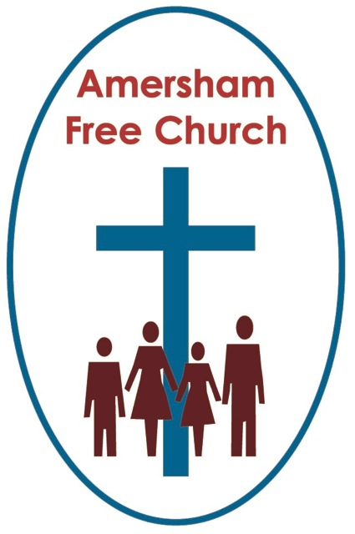
Psalm 145.8-9, 14-21
Matthew 14.13-21
3rd August 2014

Two Kingdoms

Lord God – our prayer is that the written word will point us to Christ, the Living Word – so in his name we pray and for his voice we listen. Amen.
Come with me, at the beginning and end of this sermon, into central London as we visit two landmarks around Trafalgar Square.
The first is St Martin in the Fields where last Monday we attended a lunchtime concert featuring the works of some First World War composers – one of which was the young George Butterworth. He was a friend of Ralph Vaughan Williams and made his name with settings of AE Housman’s A Shropshire Lad and a beautiful interpretation of a folk song, The Banks of Green Willow. Shot through the head by a sniper on the Somme in August 1916, just 31 years of age, he was one of the bright lights of his generation whose creative promise would never be totally fulfilled.
As we listened to his music last Monday it was poignant to learn that he probably spent the night at St Martin’s - along with hundreds of other soldiers the church welcomed - before boarding a troop train from Charing Cross onwards to France.
Butterworth’s story weaves together two themes for today – one dictated by the date the other by the lectionary. The date – especially tomorrow’s - reminds us of the human cost of war – every casualty was someone’s son or daughter, friend or colleague. Few of Butterworth’s companions knew he was a composer, they saw him as a brave soldier who by the time of his death had already won the Military Cross.
The lectionary gives us the Feeding of the 5000 – a miracle celebrating God’s remarkable generosity of spirit towards us – something so creative and uplifting – perhaps like Butterworth’s music – bringing colour, light and joy into the lives of those close by.
As we approach today’s well know gospel of over five thousand being fed, when it looked as if all on offer was a meagre five loaves and two fish – it would be good just to take a step back and remember what goes before this miracle in Matthew’s Gospel. It is the cruel death of Jesus’ cousin, John the Baptist.
It’s as if Matthew is hinting at two empires or kingdoms here and the first is Herod’s.
Herod’s rule seems to have been characterised by a nagging insecurity. He even becomes paranoid about John the Baptist and cunningly orchestrates his death during his daughter’s party prompting her to ask for the Baptist’s head to be served up on a silver salver.
This is a grotesque empire based on fear. This is a brutal kingdom in which life is held cheap by those in power.
Contrast that, Matthew seems to be saying to us this morning, with God’s Empire, the Kingdom of Heaven – as demonstrated by Jesus.
As Jesus enables over five thousand to be feed this miracle becomes a sign of God’s compassion and his call for us to be compassionate.
Warren Carter, a contemporary American bible scholar says of this Kingdom of Heaven that it has ‘Life giving structures and compassionate practices’ – I rather like that for a church’s strap line – ‘Life giving structures and compassionate practices’.
Today, standing on the eve of tomorrow’s anniversary we are so conscious of the exact opposite in that reality which is war. WW1 was one of the most costly of all time. As the empires of the world locked horns in battle it’s estimated that 10 million military personnel lost their lives in the conflict alongside 7 million civilians.
Two empires – Herod’s and God’s are brought together in Matthew 13 and the contrast couldn’t be louder.
So what of the miracle itself – the feeding of the five thousand?
Is its significance to be found in the actual way the food seems to have been mysteriously multiplied? Of course that would be a reasonable interpretation. Or maybe the greater significance is to be found in verse 20 with the telling phrase ‘They all ate and were satisfied...’
Now that may be our regular experience every Sunday after lunch but it was rarely one had by most in that peasant crowd. They lived in a ‘below subsistence’ community and food security would hardly have been typical for their villages. The norm would have been to have finished a meal still wanting more. But not here, not in this picture of God’s banquet, not at God’s hand – today they ate and were satisfied.
Regularly the bible speaks poetically of God’s generosity. It becomes a motif for the Kingdom – the idea of abundance – of all being feed, of all being free, of all experiencing life in its fullness.
That, some suggest, is the real miracle here – that folk on the margins experience God’s generous character – a glimpse of life touched by him.
Basil Hume, when he was Cardinal Archbishop of Westminster, used to tell the story of the apples. Of a small boy – I think this was autobiographical – being told about the apples in the larder – if he took one without permission God would see what he had done. For years, he said, he went around with the idea that God was a universal policeman, checking up on him. As life progressed he did what we all have to do from time to time, he re-evaluated his ideas about God in the light of experience and he rejected the notion that he was a divine policemen. In its place Cardinal Hume grew to understand God as the giver of every good and perfect gift, the generous, forgiving and welcoming father – so he would tell the congregation at Westminster Cathedral – I believe if God saw that little boy in the cupboard facing the dish of apples today he’d say ‘Take two’!
The all ate and were satisfied – the miracle within the miracle.
So how was it achieved?
Well we’re not actually told how it was achieved. The time line of the miracle runs like this: hungry crowd at the end of a long day, markets in nearby town closed, five loaves and two fish discovered in someone’s lunch box, Jesus says a blessing over the available food, gives it to the disciples who distribute it, everyone has enough, twelve basketful of left-overs collected afterwards.
It’s surely a point worth making that Jesus asks the disciples to share with him in his work of generosity. Far from being passive observers who simply brought a problem to Jesus and then stood back looking on as a miracle was performed – on this occasion they, the disciples, become an integral part of the solution.
Verse 19: Jesus broke the loaves and gave them to the disciples, and the disciples gave them to the people.
There are many, many times when I believe God calls us to participate in answering our own prayers. Active Christianity has a beating heart of compassion that gets involved in projects that promote the concept that citizens of the developing world are truly our neighbours here in the developed. We pray for our families, our communities, our churches, our workplaces, our democracy – but that isn’t the end but the starting place of our concern – having committed the matter to God we then work hard as listeners, encourages, fundraisers and peacemakers in these contexts – somehow seeking, with God’s help, to make a contribution towards answering our own prayers.
Jesus gave the loaves and fish to the disciples and they then took it round to all the people.
Two empires – one Herod’s, the other God’s. One so full of a power struggle the other characterised by generosity of spirit.
But the truth is that neither empire is entirely self contained – they can both impinge on the other. God’s kingdom can bless Herod’s bringing restraint and redirection – but then Herod’s kingdom sometimes damages God’s so that in the church, for example, we too become obsessed with power or negativity.
All of us, I guess, know the challenge of these two kingdoms and the conflict they sometimes bring to our personal and collective decision making.
So come with me to the second landmark near Trafalgar Square as we close. The statue of Edith Cavell in St Martin’s Place just opposite the National Portrait Gallery.
This Christian nurse from Norwich worked in German occupied Brussels. She was protected by the first Geneva Convention which grated security to medical personnel working behind the lines. But that protection ran out if she were to help British, French and Belgian prisoners escape to Britain which she did.

This nurse, the daughter of a Norfolk vicarage spent her years in World War One caring for German patients as well as assisting British ones.
When it was discovered she was doing the later she was convicted by a French court of being a collaborator and sentenced to death in October 1915. The night before she died, being visited by the chaplain, she said: Patriotism is not enough. I must have no hatred or bitterness towards anyone. Words engraved on her memorial in central London and spoken at her state funeral in Westminster Abbey, when her body was returned home after the war.
Those two empires, Herod’s and God’s had collided in Edith Cavell’s life – and she coped with that reality by caring equally for German and British sufferers.
When such a collision comes our way, may we embrace God’s generosity and do all we can to answer our own prayers – in the name of the Father, Son and Spirit. Amen.
Ian Green Amersham 1st August 2014

