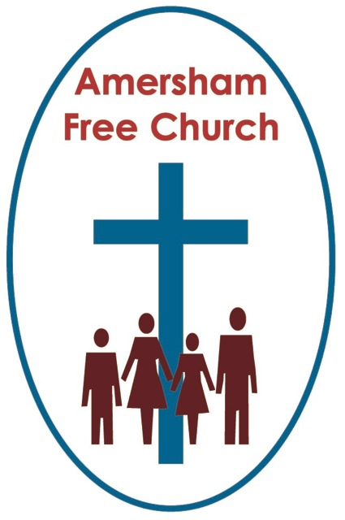
Matthew 28
15th June 2014

The Community of The Trinity

Lord God – our prayer is that the written word will point us to Christ, the Living Word – so in his name we pray and for his voice we listen. Amen.
Perhaps many preachers will begin their sermons today with a well-known story told by Augustine of Hippo. Of the day he was walking along the beach and saw a girl playing. The child made a hole in the sand, ran to the sea with a little cup, filled her cup, came and poured it into the hole she had made in the sand. Back and forth she went to the sea, filled her cup and came and poured it into the hole. Augustine went up to her and said, "Little child, what are doing?" and she replied, "I am trying to empty the sea into this hole." "How do you think," Augustine asked her, "that you can empty this immense sea into this tiny hole and with this tiny cup?" To which she replied, " And you, how do you suppose that with this your small head you can comprehend the immensity of God?" With that the child disappeared.
On Trinity Sunday – the only festival of the church based on a doctrine rather than a bible story, we are in the realm of mystery, we are talking of concepts that outstrip our words and ideas that do not fit neatly into the rationality of our small minds.
One God, not three – and we call this a Community of The Trinity.
If we Christians find this a tough doctrine to put into words then our closest relatives – in terms of faith structure – our Jewish and Muslim friends find it an almost impossible concept, at least if we want to say that we , along with them, are still a monotheistic faith. How can you, they say, maintain you believe in one God if he is a committee of three people, God the creator, God the Son and God the Holy Spirit?
Well perhaps we ought to begin by saying quite firmly that God is certainly not a committee and it almost sounds blasphemous suggesting it!
But, by the same token, he also isn’t monochrome. For example it’s certainly true that both in Judaism and Islam there is already a twofold understanding of God. That is he is transcendent – in the words of a children’s song – he’s a great big God. Or as the little girl put it in Augustine’s myth story: how do you suppose that with your small head you can comprehend the immensity of God? Yet, both Jews and Muslims also hold dear, albeit in tension with that first idea that God is transcendent, the notion that God is immanent – that he is present, or close to us, in every aspect of the universe – present in the laughter of children and the rustling of the leaves in the wind. This is the paradoxical nature of God, then, says the three great monotheistic faiths of the world, he has at least a two- fold nature – he is both close to us and yet far away, he is the creator of the galaxies yet present with us in every breath we breathe.
Now we might, using Trinitarian language say that sounds rather familiar – that’s a description of God the Creator – so majestic and eternal, and God the Holy Spirit, with us every day and in everything. So it’s to this two fold understanding of God that Christians add a third expression – Jesus.
Without Jesus we might have been happy to stay at two but with Jesus our monotheism has to become three – this morning’s sermon is getting more and more like a maths lesson!
Jesus, for us, is the most precious revelation we have ever had about God. In terms of our faith tradition it’s our understanding of Jesus that literally makes us ‘Christian’. It’s his life and teaching that inspire us in our search for truth so in a way the Trinity is a witness to the centrality of Jesus for Christians.
That said we have often struggled to get the language right in expressing what we believe – and perhaps the greatest stumbling block in understanding the Trinity is to use its ancient definition as being One God in Three persons. It’s the use of the word Person that can be confusing. There is something complete and separate about a person – we don’t share ‘personhood’ with anyone else – so I’m always ‘my own person’.
In Greek and Latin the word translated person is quite different from its modern meaning. It was the fourth century when the Church started talking about One God in Three Persons – and at that time it meant ‘persona’ and was literally the mask worn by actors on an ancient stage. This persona mask wasn’t there for the sake of concealment but rather it was the mask, the persona through which an actor spoke. The character played by the actor was made known, revealed through the persona mask.
So this is how Marcus Borg (currently my favourite theologian!) applies this to the Trinity: the ancient meaning of persona suggests that for Christians the one God is known and speaks in three primary roles or ways: as creator and the God of Israel, in Jesus and through the Spirit.
So although I love it, the Icon of The Hospitality of The Trinity – currently on our website and printed in outline on today’s order of service uses the idea of person in a way that’s rather modern – three individual people sitting around a table. Whereas in the fourth century theologians had a different idea – that of one God, known to us in three primary ways.
Of course it is true that look as hard as we might we’ll never find the actual word Trinity in the bible. Instead we have descriptions of God in these three primary ways. St Paul uses them in the formula of The Grace with which he often signs off his letters and which we’ll use in the communion service later on: The grace of our Lord Jesus Christ, love of God and fellowship of the Holy Spirit – interesting, isn’t it, that for Paul Jesus is placed first in his Trinitarian greeting. And then, of course, there is today’s lectionary reading. Matthew concludes his gospel on a mountain with the words of the Great Commission. Whenever Matthew wanted to say something important he always placed it on a high point, somehow echoing Moses receiving the Ten Commandments on Mount Sinai. So here on the mountain Jesus tells his followers to go and make disciples baptising them in the name of The Father, Son and Holy Spirit.
Well if you’ve kept up with me so far this morning I suppose it’s all been rather technical so far and you might be tempted to go home and say today the sermon didn’t say much about how we might live life with faith in the here and now. So let me in these closing moments rather chance course.
So far we’ve been thinking of Trinity in terms of the external manifestation of God – but what does it say about his internal nature?
Well, once again it’s a tough call for us to define our creator but one of the most inspiring things I believe the Trinity can teach us is that the very essence of the God we worship and serve is that he is a God of Community and that the very idea of Community is intrinsic to creation – we might say part of our DNA is that life is enhanced and lived to the fullest in Community.
Of course we are in the realm here of pictures and concepts – the idea of a Triune God, working together as Father, Son and Spirit – is the picture of a divine Community.
I suspect that even though we know living with others is never always easy we come to learn it is ultimately the context in which we share our greatest joys and sorrows. When we talk of that ‘War Time Spirit’ we’re usually referring to a sense of community in which people put the needs of others before themselves. Earlier this year as the Somerset Levels flooded I phoned a minister friend on the edge of it all and she told me no real help was needed from outside because people in the community had rallied round.
And we all know the heartache of when a family community is broken up or a nation goes through civil war pitting the community against itself.
Today on this Trinity Sunday I believe we are being asked to reaffirm that Community is at the very heart of God. Even as he works in this Triune way as Father, Son and Spirit, so we are asked to value and explore what it means to live not isolated, separate and self-focused lives, but to journey together in faith, to stand alongside each other in compassion and to live always with the idea that something of God is to be found in our experience of Community.
Of course that’s the narrative that runs right through the bible. It’s the story of the God the Father guiding the People of Israel, it’s the story of God the Son working with the twelve disciples and it’s the story of God the Holy Spirit filling the Church with love, light and life.
I’m glad we live here at Amersham Free Church with the aspiration that we might be in the process of becoming a Community for The Community – surely something worth affirming on Trinity Sunday.
So may this truth that God has become known to us in three primary ways not only affect our beliefs but also our living - and on what week would it be more appropriate to say we pray all this may be true of us and for us – in the name of Father, Son and Holy Spirit. Amen.
Ian Green Amersham 13th June 2014

