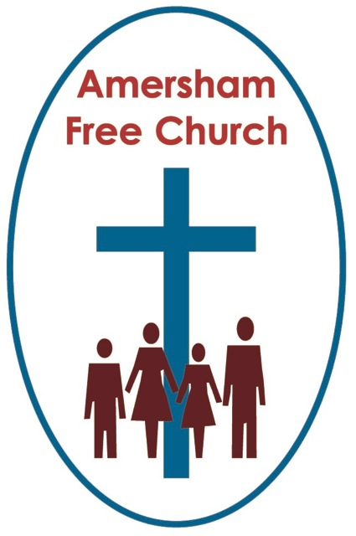
4th May 2014
Luke 24. 13-35

The Journey to Emmaus –
taken at the ‘speed of love’

Gracious God – we open the bible and long to receive your word – open, we pray, our minds and hearts to receive that word with all its comfort and in all its challenge. Amen.
Only Luke reports it, only Luke needs to. That’s because his whole gospel is built upon the idea of going up to Jerusalem and then returning from it. But this time it felt different. They come away from the centre of the Jewish universe disappointed, deflated, fearful and confused.

This was a sad road to Emmaus.

Cleopas and his friend (we don’t know his name – or might it intriguingly have been a ‘she?!) were disciples of this Jesus from Nazareth. Not part of the inner team of twelve – but still disciples, still believers, still followers.
It’s the evening of Easter Sunday and they are confused by all that’s happened since last Sunday. One they had cheered and welcomed with palm branches had been set up, by Judas – of all people – one of his most trusted friends – betrayed for twenty pieces of silver.

Jesus had died on a cross between two criminals – even then he was still changing peoples’ lives and one of the criminals believed in him.

But as Jesus breathed his last it was as if their dreams died with him.
Well – when you are discouraged and confused sometimes it’s good just to get away and go for a walk, visit somewhere else and then come back home to your routine. And that’s what Cleopas and his friend were surely doing.

Walking as the sun set – 7 miles – west of Jerusalem – towards the sea – to a village called Emmaus.

As they walked – so they talked – and slowly they realised someone had joined them on the road – a stranger – not recognised maybe because of the bad light of dusk, or maybe because of that mysterious post resurrection body of Christ’s that we know so little about.
I read a comment on the story this week that chimed with me. The idea that the stranger beside the Emmaus disciples walked at the ‘speed of love’. Isn’t that a great phrase! He doesn’t walk in front of them, he isn’t too fast for them – instead God always walks at the speed of the slowest.

He asked them what they were discussing and they told him they were talking through the news – you know the things that had happened this last weekend in Jerusalem. And the man said, and they couldn’t quite believe this: what things?
Surely everyone knew – but no – he didn’t! So they told their new walking companion about Jesus’ unjust trial and his death – they even told him about the current gossip – some of their friends had visited the tomb earlier today and came back with the news that he had risen again. Apparently – and this took some believing – angels had told them. But Cleopas and his friend hadn’t seen any angels – so they remained confused, upset and yes, fearful.
The phrase that just rings out here in Luke is; ‘we had hoped’. It’s in the imperfect tense – not the future tense with everything put right – instead everything seems to be on hold, gripped by an air of confusion and most definitely tinged with the atmosphere of disappointment.

One bible commentator puts it like this: This is one of the things I love about the gospels: they know what we sometimes don’t dare to say.
In other words, most of Easter Day for these disciples wasn’t a day of rejoicing but of fear, disappointment all mixed up with a heavy dose of confusion.

For us, metaphorically, the road to Emmaus can last a long time. Perhaps as you sit here in church this morning you are struggling with the theme of resurrection even if it is its season. As you contemplate living with a health issue, the disappointments that family life can all too suddenly bring, the pressures of a job – maybe this phrase rings true for you: I had hoped.
Remember that Jesus walks at the speed of the slowest.
And then the man in the shadows, walking with them, he begins to put the jigsaw pieces back together. At first it appeared he knew nothing about Jesus – but as he talked they realised he knew a great deal.
He spoke of the Old Testament prophesies that God would send his Son. A Son who would show love and forgiveness even to the point of death. But this Son would rise again. The message of the resurrection is that God wants to give us all his new life and the possibilities of new beginnings.

It was all starting to make sense. They loved talking to this man – he was going on to the next village but Cleopas and his friend persuaded him to call in with them at Emmaus and have supper. They would pay for the meal but wanted him, their guest, to say grace. So he prayed and then he broke the bread as he said a blessing – and then he was gone.

Yet at that moment – in a flash of understanding – a eureka moment – they recognised him. Was it the nail prints in his hands – had they been onlookers in the Upper Room as Jesus broke the bread of that first Communion Service? They recognised that the one they had been talking to was the resurrected Lord Jesus Christ.

Those reports were true. What the women had said earlier in the day was true! He isn’t dead. He is alive!

They had just walked seven miles in despair. But now, with this news, they got up, turned around and walked seven miles back to Jerusalem in joy! And once back in the city they had one message for the others: The Lord is risen.
I love the Emmaus story. I love the fact that on that first Easter Day Jesus didn’t only appear to the well known disciples like Mary and Peter – he also showed himself to Cleopas and his unnamed friend.
I like the fact that Jesus helped them make sense of the facts. Lord Darling, a one time Lord Chief Justice of England, once said that the evidence for the resurrection is overwhelming! Well you could write many essays with that as the opening line! What I do think is that Jesus, by the Holy Spirit, can still come alongside us today and make this resurrection real.

The cross was an instrument of execution – yet on it Jesus does something that is truly transformative – he forgives. And he asks us to enter into his death – remember that invitation to take up a cross. And as we do so to live lives of forgiveness.
Jesus takes these events, turns them on their head and brings hope out of despair, life out of death.
The cross and the empty tomb become the epicentre of the Christian story – they can become the foundation of our stories.
A writer I much respect, who has written a super book on the last week of Jesus’ life, John Dominic Crossan, calls the Emmaus Road story "the metaphoric condensation of the first years of Christian thought and practice into one parabolic afternoon," to which he famously added, "Emmaus never happened. Emmaus always happens."
Well, whether or not we consider Emmaus an historical moment it’s a wonderful thought that this story has been lived out a million times since Luke first wrote it down.

We encounter a truth in the Jesus story that intrigues yet also mystifies us. We ponder it, wrestle with it, we even try walking away from it.
And then maybe we join others who are doing the same thing and we feel we’re on a journey together – and slowly, it begins to come into a clearer focus and no longer feels quite so strange. And as bread is broken – in the experience of worship and prayer, there is a meeting in our mind and our heart is warmed and we sense hope and love and the touch of the divine upon our lives. As it’s as if we too have met with the risen Christ.
Or maybe for us it isn’t just one journey but many journeys – and maybe today we are still closer to Jerusalem than Emmaus but we know we are on the road and Jesus is walking with us, at the speed of the slowest – the speed of love.

May it be for you a good journey – in the name of the Father, Son and Holy Spirit. Amen
Ian Green 1st May 2014 Amersham

