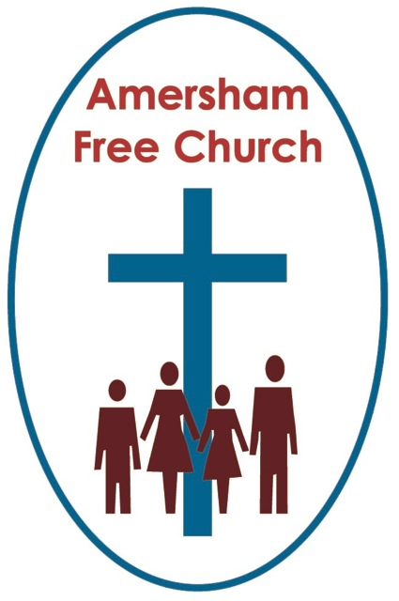
Matthew 29.10
20th April 2014 Easter Day
Easter Hope

Gracious God – we open the bible and long to receive your word – open, we pray, our minds and hearts to receive that word with all its comfort and in all its challenge. Amen.
On Wednesday 19th February 1997, the day after the death of Deng Xia Ping, this was the headline in the morning paper: Chinese instability feared after beloved comrade passes away.
Some might have thought that a fitting headline for the followers of Jesus the day after Good Friday. What now? Instability – confusion – panic –disillusionment for those who believed in Jesus as Messiah now the beloved leader was dead.
Over 2000 years later another Easter Day has dawned and we’re still in celebratory mood! The alleluias have not faded and to the refrain: Christ has died we have added another: Christ is risen!
In all sorts of ways Easter defines faith. That is - what we believe about it, what it means to us, the place it has in our faith scheme – goes to the core of what we think Christianity is about.
So here’s something I believe on Easter Sunday morning: That the darkness will never extinguish the light.
There are times when we fear that darkness is winning. St John of the Cross describes those moments as The Dark Night of The Soul. And I suspect that’s what it felt like for Jesus’ disciples at the end of Good Friday because throughout history a crucifixion had normally been understood as a full stop.
In 1863 a French biography of Jesus ended with Good Friday and on the next page was written the word ‘Finis’ – the end. That’s it – all over – a crucifixion – rabble rouser problem solved for the Romans and humiliating put down for yet another of Israel’s false dawn Messiahs.
But that’s not what the cross stands for in Christianity.
Instead we dare to believe that the cross speaks to us about love, goodness and forgiveness.
And that through the cross – and in the reality which is proclaimed through the resurrection – darkness has not snuffed out the light which still shines at the centre of the universe – a God of light – A God of truth and a God of justice.
Jesus never proclaimed that living with such a belief would be easy. Indeed, just like every life his own had intense moments of confusion, anxiety, doubt and darkness. But at such times don’t we also see in Jesus a faith that is sustained by prayer, a pilgrimage that is shared in community. And of himself, describing the Kingdom he personified, he says: I am the Light of the world.
I read the other day that before Christ’s coming the Tuscans always made their tombs face the west. Death, for them, was the close of life’s day. But after his resurrection they made their tombs face east, towards the coming light – facing the promise of a new dawn.
Today I believe that light is stronger than darkness.
And here’s something else I want to affirm on this, the most important Festival of The Church: today of all days I believe in hope rather than despair.
The Resurrection brings hope. On the cross Jesus makes an astounding promise to the penitent thief – it’s a promise that can profoundly mould our understanding of life and death: ‘today you will be with me in paradise’. On another occasion he reassures his worried and anxious followers that there were many rooms in his Father’s house and he was going to prepare a place for them.
Christianity has this theme of hope written through its core. Hope about life today and tomorrow.
Last weekend we walked over the Millennium crossing – the one that will for ever be remembered as the wobbly bridge – from Bankside to St Pauls and for the first time I looked up and saw the great Phoenix carving across the South door of the cathedral. Wren no doubt incorporated it to remind succeeding generations that this House of Prayer rose from the ashes of The Great Fire of London.

The Phoenix. It was a symbol adopted by the early church for Easter. The bird that dies and then rises again unconquered. This is the church’s Phoenix Day – the Day of Resurrection when we proclaim that however hard going our personal struggles and however problematic our world issues – we believe in hope rather than despair. It is the hope and light from a sunrise in the garden.
This Lent many of us have had the huge privilege of being led by Erna through the film The King’s Speech. We have reflected together on the themes from the film as it described the journey taken by King George 6th from stammering prince to inspirational monarch. A hard road, a difficult journey – one filled with wonderful people all with their own story within his story. And in the end – the film – proclaims – this Sovereign finds his voice.

The history books tell us that when he died George 6th, the present Queen’s father, left instructions that an Easter hymn should be sung at his funeral service in St George’s Chapel, Windsor - The Strife is o’er the battle done. Perhaps appropriate for a war time monarch who had battled his way through many days of strife. And each verse is full of Easter hope, bursting with Christian conviction, concluding in verse five with these tremendous words:
Lord, by the stripes which wounded thee, from death’s dread sting thy servants free, that we may live and sing to thee – Alleluia!
Today I believe that light is stronger than darkness, that hope is stronger than despair.
And finally the thought that Easter is as much to do with today as it is with tomorrow.

Just think of the story we’re remembering. Jesus appears to Mary in the garden – on her arrival she is desperately sad but then she encounters not the gardener but her risen master and she is changed. She runs back to the city to relay the news to Peter.
Easter isn’t just a hope for tomorrow with its promise of resurrection – it’s a blessing and a joy for today. Think of Thomas – his story is a week on from Mary’s and for seven days he’s lingered in his doubts – until he comes face to face with the master and believes.
The message of the resurrection changed the disciples there and then. It altered their perception and inspired their actions. Here and now they believed and nothing was the same again. It can, my friends, be the same for us.
An Anglican order of monks, based at Mirfield in West Yorkshire has a wonderful name – they are called The Community of The Resurrection. It’s a name I’d love to give to any church. And two great Christian leaders were trained there. One was Archbishop Trevor Huddleston that great champion against apartheid in South Africa – and the other is the dancing Archbishop Desmond Tutu. Both these fine servants of Jesus worked tirelessly in the name of the resurrection and all it stands for, to bring about a change of attitude for today – for them the hope at the centre of Christianity wasn’t reserved for some celestial eternity – it was about bringing in something of the kingdom today - on earth as it is in heaven.
Christian Aid sum it up so beautiful with the catch line: We believe in life before death.

The resurrection helps define us – it makes a difference to the way we live, the attitudes we hold and the actions we perform. It makes a difference to the sort of person I am on Sunday 20th April 2014.
Like Mary and Thomas, like Trevor Huddleston and Desmond Tutu we also are members of the Community of The Resurrection – for we are Easter Morning People.
So today we have gathered to sing our alleluias and to affirm again that light and hope are stronger than darkness and despair – and to affirm that not just as a future longing, but as a present reality.
I want to end with a story I came across a few years back – it may not be the most theologically insightful but to me it sums up so much of what I think this day is about.
It’s said that a church office in North Carolina had an Easter display one year of a life-sized Jesus cradled in his mother’s arms. He was shown just taken down, dead, from the cross. And that year an old southern lady popped her head round the church office door and said to the staff: Is that Jesus dead – yes. Killed by the bad men – yes. Dead and gone forever – no. Lives again then – yes. Surely, they said, you must have heard of the resurrection?

Heard it before, she said. A million times before – but I just love hearing it again!

Christ is risen! Alleluia!
Ian Green Amersham 19th April 2014

