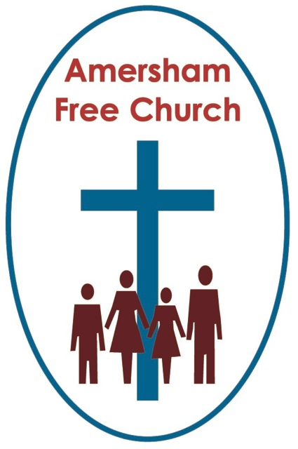
Psalm 31.9-16
Matthew 21.1-11
13th April 2014

Two Processions – Palm Sunday 2014
Gracious God – we open the bible and long to receive your word – open, we pray, our minds and hearts to receive that word with all its comfort and in all its challenge. Amen.
I’m not that wild about crowds.
Physically it can be a claustrophobic experience being caught up in one. And metaphorically I’ve never been much inclined to following the crowd – preferring, most of the time, to plough my own furrow rather than jump on someone else’s band wagon!
And crowds can have their own subversive dynamic. I well remember my German teacher telling us of her own school days and the pressure she felt to join the Hitler Youth. As uncomfortable as she was this was a crowd that everyone else expected her to belong to.
As we enter Holy Week we’ll find it hard to get away from the crowds that fill the gospel narratives and the first one we encounter is the hosanna chanting and leaf waving Palm Sunday one.
Palm Sunday - what did they make of it, what did Jesus mean by it and how do we understand it?
Its other name is The Triumphal Entry and just maybe that sets us on the wrong track straight away for the only crown at the end of this procession is one of thorns not diamonds.
I think it’s a little tough to work out the logistics of Palm Sunday. Every gospel includes it in and seems to imply Jesus was meticulous about its planning. He rides a donkey – sometimes used by Israel’s royalty in days gone by, but more recently just a humble beast of burden. Nevertheless asses and donkeys were so valued in the Jewish tradition that in Deuteronomy 5 there’s a special instruction to give them a Sabbath – one day off in seven.
Jesus never speaks of The Kingdom of God in terms of power and I suspect he would have been uncomfortable calling this arrival in Jerusalem his Triumphal Entry.

That’s because so much of this day and the ones that followed were about challenge. Jesus in his quest to speak about and embody this Kingdom of God confronts both the Temple Leadership and Roman Authorities. He challenges their understanding of power.

Yet however convinced he seemed I don’t think Jesus comes across in Holy Week as triumphalistic.

He has already wept over Jerusalem. And he seems to have positively cherished meeting Nicodemus a member of the Sanhedrin – a body that could be viewed as the so called enemy.

As one commentator has so perceptively put it: Confronting one’s own faith and tradition is always painful.

Jesus’ whole life had been with these people, with this faith paradigm, with this image of God. Yet on Palm Sunday he enters ancient, holy Jerusalem and knows that his message is intrinsically one of challenge – his actions will be interpreted as those of confrontation and his destiny in all probability will not be a seat in the Temple but a cross on Calvary.
I wonder if this is not also a journey we should make from time to time. A re-examination of our own faith and traditions. A willingness to let go of some of the stale and failed understandings we hold onto about God alongside a willingness to open our minds to new insights borne of the struggle from our adult and maturing faith.

What did that bible commentator say: Confronting one’s own faith and tradition is always painful.
Last year during Holy Week I accepted an invitation from the South Bucks branch of Liberal Judaism to attend their Passover which they held in our church hall. As I’m away this week Erna will be attending as their guest this year. It was such a delight to be with them and sense just how much they, as Liberal Jews, were trying to apply their faith to the reality of the 21st century. So at one point in the evening their visiting Rabbi said: We’re not looking any more for a Messiah riding upon a white horse but for a Messianic age that will touch the world with peace and love.

Theologians might call that a brave hermeneutic – a courageous interpretation of the Jewish Scriptures.
I sometimes wonder if I have as much openness of spirit – to revisit my faith and my tradition and ask similar questions – what does it mean for me to believe in, to be part of, to pray for The Kingdom of God – and what might that actually look like and feel like in our 21st Century world.

And yet I sense there is a message for us from that original Palm Sunday that can still inspire our faith journeys today. It’s the concept both proclaimed and exemplified by Jesus that God’s Kingdom isn’t about manipulative power but loving service.
It’s been a year now since Pope Francis and Justin Welby took up their respective roles of leadership in two worldwide Christian communities. And both spoke to us of service as a central tenant for our faith.

As 150,000 gathered last April in St Peter’s Square for the investiture of a new Pope, Francis said in his sermon: Let us never forget that authentic power is service.
Two days later at Canterbury in the presence of two thousand people the new Archbishop was greeted at the West Door, in a wonderful new twist on the liturgy, by a seventeen year old girl who asked him: Who are you and why do you request entry? To which he responded: I am Justin, a servant of Jesus Christ, and I come as one seeking the grace of God and travel with you in his service together.

If you ask me: why do we here at Amersham Free Church provide LunchBreak every Tuesday of the year, why do we host a Child Contact Centre, why do we support a Food Bank, why do we give away 24% of our income – the answer has but one word – service. Because in some small way we believe that supporting the Christian Aid project for Kenya, offering a welcome at Tea at Three, opening our doors to the Parent and Toddler group Fun at One – has something of The Kingdom of God about it.
A verse from a modern communion hymn puts it this way: For service too is sacrament.
In their book The Last Week, Marcus Borg and John Dominic Crossan talk about Palm Sunday and they make the point in the book that on that day there were actually two processions taking place.
One they characterise as the Peasant Procession that Jesus was leading, coming down the Mount of Olives making its way into Jerusalem for Passover.
The other came from The West – as it did on this day every day and it was the Imperial Procession. At its head was Pontius Pilate, Roman governor, just come up from his usual more conducive seaside residence of Caesarea Maritima, leading a column of cavalry and soldiers. Come up to supervise Passover.
Two very different processions—not just coming from different directions—but about difference in every way imaginable.
The Peasant Procession, Jesus-led procession, was proclaiming the Kingdom of God. The Imperial Procession was proclaiming the power of the Empire. They couldn’t have been more different. And it was those two processions converging on the holy city of Jerusalem that set the context for the conflict that would ultimately ensue and result in Jesus being crucified.
Which procession will you join?
On the surface there was no contest. At the head of one rode a radical rabbi on a mule, at the head of the other comes the most powerful man in Idumea, Judea and Samaria. One will click his fingers and slaves will run to his every command, the other will wrap a towel around his waist and wash the feet of his disciples.

Looks can be deceiving. So as we enter this Holy Week and continue to make our way to Jerusalem, and Calvary and the Cross, the question is: Which procession are we joining?

What inspires us, sustains us, nurtures us and moulds us – power or service?
A question worth pondering – may it be for us a Palm Sunday challenge in the name of the Father, Son and Holy Spirit. Amen
Ian Green Amersham 11th April 2014

