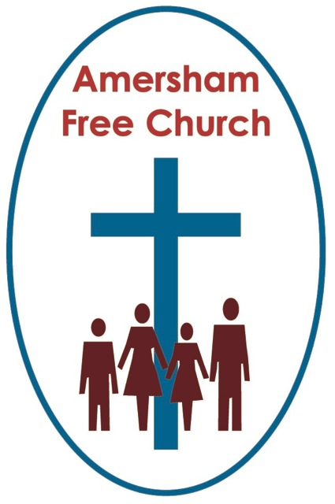
Ezekiel 37.1-14
John 11.17-46
6th April 2014

Jesus Wept
Gracious God – we open the bible and long to receive your word – open, we pray, our minds and hearts to receive that word with all its comfort and in all its challenge. Amen.
Over recent weeks we’ve taken advantage of the cinema nights at Chesham’s Elgiva Theatre and watched some wonderful films with poignant themes. As we shared Philomena’s journey to find her son, The Railway Man’s struggle to forgive his Japanese torturer or the personal drama behind the 1853 memoir by Solomon Northrup in 12 Years a Slave we left feeling we’d been on an emotional roller coaster.
At the end of each of these three evenings, as the lights came up, it was obvious that many in the audience were wiping away the tears. As we talked on the way back to the car it hardly seemed appropriate to ask each other if we had ‘enjoyed’ these evenings – somehow our appreciation of them went deeper than that. These films had invited us in – they had beckoned us to glimpse the struggles of others – the quest for truth, justice, forgiveness and reconciliation. And somewhere in each of these stories we encountered great dignity even in the face of great sorrow and it made us cry.
Today’s gospel reading is, for this Bethany family, an equally poignant and sad time. Only John records this story of Lazarus’ untimely passing. An event, when coupled with his rising that both anticipates Holy Week and, in part, actually precipitates it.
And it’s here that we are told, in the bible’s shortest verse, that Jesus wept.
What, I wonder, brought him so low? Maybe an appropriate question to ask on this fifth Sunday in Lent, often known as Passion Sunday.
You can’t, I think, escape from a sense of immense struggle as Jesus draws ever closer to the events of Holy Week.

By now, in John’s account, he and his disciples have moved away from Jerusalem because they knew they were being watched. It was no longer a safe place for them.

But somehow the Bethany family were in the loop and they knew where to contact Jesus with the hope that he might come back down south for them and for Lazarus.

Some bible commentators argue that John’s gospel is set up with this north south split running through its chapters. In the Judean south there’s the religion of Empire exemplified best by an awe inspiring temple and status grabbing high priesthood. The religion of Empire is threatened by the radicalism of Jesus and it wants him silenced.

And then there’s the north – what commentators call the Galilean mindset. A more flexible, open minded approach to faith, one that might at least give a wandering rabbi a chance to speak about love, equality, mercy and justice.

Of course such generalisations always fall down. Jesus was, for example, chased out of his local northern synagogue for being too radical – and the family at Bethany lived in the south even though they are thought of as belonging to this open minded northern Galilean tradition.

By the time we arrive at John 11Jesus is struggling. Jesus is weeping. Should he return to the south? He lingers longer than the sisters would have liked in an episode of the story we don’t quite understand.
At times he struggles as much with his friends as his enemies. His disciples, apart from Thomas, urge him to stay put and leave Lazarus in the grave and even when he arrives in Bethany Martha misunderstands what he says about resurrection.

Yet Jesus is not deterred by the disciple’s caution and he goes to Bethany because he is the one who came to bring life in place of death, love in place of hate, and joy in place of sorrow – so he can’t keep away.
And once there he weeps.
Now John is keen to paint a picture for us of Jesus that will inspire. Not for him the parables of the other gospels, instead he opts for miracles – sometimes called signs.
That’s why you’ll occasionally hear the first twelve chapters of John’s Gospel called The Book of Signs – that’s the itinerant ministry of Jesus and from chapter thirteen onwards when we have the Passion and Resurrection narratives these chapters are known as the Book of Glory.

So, the first sign was in Cana of Galilee as Jesus turned water into wine – the seventh will be the raising of Lazarus and the eighth will be his own resurrection on Easter Day.

Through the miracles, in these signs Jesus – hints John – is revealing his glory – he is showing us who he is and what God is like.

Now maybe this is rather impertinent of me this morning but I’d like to suggest a ninth sign – that Jesus wept. I know it’s not a miracle but doesn’t it reveal to us so much about the Christ-like God we worship. A God who weeps alongside us, who carries our sorrows and feels our pain.
The Judea-Christian understanding of God was very different to concepts held by the majority in 1st Century Roman and Greek society. Their prevalent idea was of stoical gods, deities that were aloof, untouched by human pain. But this Jesus weeps.

Sometimes I suspect we all rush too fast towards themes of resurrection in our longing for a brighter dawn. And by doing that we might just miss the significance of this short verse. We might also pass by Holy Saturday – that day of waiting between Good Friday and Easter Sunday. For most of us Holy Saturday is at least in part a daily reality. We carry in our hearts a bereavement, our minds are full of unanswered questions, our spirits are anxious with fears.
Where, we ask, is God on Holy Saturday?

Maybe today’s story whispers to us that God is waiting with us, holding us in this fellowship of tears, alongside us in the pain – the Wounded Healer, The Suffering Servant, the Jesus who weeps.
For such a short verse – it can become a major building block of our faith.

However, this narrative doesn’t actually end with Lazarus emerging from the tomb. Instead it concludes with two endings, or reactions.

They both have to do with resurrection – and in so many ways the themes around the rising of Lazarus will meet us again in a fortnight’s time on Easter Day.

So the first ending is one of rejoicing. Jesus brings joy to a family in sorrow as their brother is returned to them. That’s what Jesus is about. The African American church tradition puts it this way: Where the world places a full stop God introduces a comma – suffering does not have the last word.

And it’s in this passage that we encounter that verse which is so often read at funeral services. Jesus says: I am the resurrection and the life.

The Christian response to death isn’t to ignore it, or glibly say it doesn’t matter. Jesus wept – and in so doing sanctifies all grief. He knows how hard bereavement is. We worship a God who understands.

The Christian response to death is surely to point to Jesus Christ – to trust in his promise that he is the resurrection and the life.
So for this family in Bethany the story ends with joy.

But then there is verse 46: Some of them went off and reported what he had done. They set in train the events that would lead to Jesus’ arrest and execution

So this second ending to the story deflates the moment and I wonder if this might also have been a reason for the earlier weeping. Jesus knew that even compassion can bring about complaint. That love can be misconstrued.

Yet he chooses love – as we are called to do. He chooses life. He chooses compassion. And the shadow of a cross begins to fall upon his choices.
John tells us the story of Jesus – John and asks us to respond. What do we make of this Galilean preacher? What ending to the raising of Lazarus do we choose for ourselves?
Do we believe he was the door, the shepherd, the living water?

Do we see in the miracles a Jesus who makes a wedding feast joyful, who feeds a crowd with sustaining food, who opens up a world’s beauty to a blind man, who restores a family’s hope with the raising of Lazarus?

Do we believe in this God of compassion and love- who has come to bring us life in all its fullness?
One commentator has put it like this: John’s gospel makes claims, at worst they become slogans of propaganda. At best we tell the whole story and know its summary: God so loved the world: God is compassion. That is the light that challenges darkness, the truth that challenges falsehood, the caring that challenges abandonment – and so leads from death to life.

May it be so for us in the name of The Father, Son and Holy Spirit. Amen
Ian Green Amersham 4th April 2014

