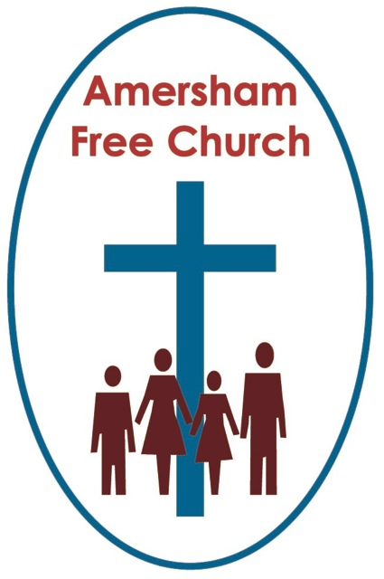
Isaiah 42.1-9

Matthew 3.13-17
12th January 2014

The Baptism on Jesus in Matthew

Gracious God – may your Living Word come to us afresh this morning – so touch, we pray our minds and hearts with your grace and truth – through Christ our Lord and in the power of your Spirit. Amen
Looking through the BBC Symphony Orchestra’s schedule this week I was intrigued to see the language it employed. They have two days this coming spring at the Barbican entitled Immersion Days! As a Baptist Minister I had to look twice. Actually these are not liturgical occasions but opportunities for us to go along and be ‘immersed’ in the music of a particular composer, listening to lectures in afternoon and attending a concert in the evening – nevertheless an interesting use of language – Immersion Days.
Well today we heard of Jesus’ baptism in our gospel reading – as we often do at this time of year in the lectionary cycle. Anyone remember last year’s sermon on this theme – no need to put up your hands!!
Christian baptism – built as it is on the ancient Jewish practice of ritual washing – is a sacrament with different emphases. Its meaning can be diverse.
The mere presence of water – as in most religions – means that spiritual cleansing is important to us in our baptism. If our baptism was by full immersion then we went under the water and came up – a symbolic death and resurrection moment. Or maybe we brought our baby to AFC for Christening with all its symbolism of entry into the Christian family of The Church. Perhaps for you baptism was that moment you said ‘yes’ to God in obedience and with commitment – or maybe that came together at your confirmation and church membership reception as you reaffirmed vows made by your godparents.
All of these rich experiences are precious to us in our pilgrimage – we cherish them and can be sustained by their memory.
But what of Christ’s baptism? Should it really have happened at all or did he go a little off message at this point?
Certainly there’s more than a hint that the gospel evangelists are surprised by it and ever since commentators have had to work hard at trying to understand what was actually taking place that day on the banks of the Jordan.
And I suspect John the Baptist was also surprised by the way the day turned out. That’s because there’s quite an edge to John’s ministry. His call is to repentance and he doesn’t pull back from criticising the Scribes and the Pharisees. The Judgement of God is a central plank in his belief system.
Baptism, for John, was a public declaration that you had repented of your sins. John was probably happy to baptise anyone who requested it – but then Jesus came along – and Jesus requested it – John, quite understandably I think, seems to stumble and hesitate at this point. Is it appropriate to baptise Jesus? Perhaps John thought instead of going in the water Jesus should have stood with him on the bankside and joined him in his preaching crusade doubling up his message about judgement.
Yet that isn’t what happens. Instead of criticising sinners Jesus identifies with them and enters the Jordan to be baptised alongside them. And at this point doesn’t the message of Christmas come ringing back into our ears – the God who comes alongside us, the God, who in Jesus Christ shares our life – this Jesus comes into the river of life and shares our baptism.
Quite a different picture of God and maybe John was shocked by this. But then all of us can be very prescriptive about the way we think God should be working and we are surprised when his doesn’t take up our agenda with the enthusiasm we might expect.
So instead of a Jesus standing on the banks preaching judgement we encounter a Jesus in the river sharing the baptism of those around him.
I think it’s a picture, a metaphor of incarnation. Of the way God comes alongside us in our moments of repentance – not to condemn us because of our failure – but to take us through the river, to offer us cleansing, and walk with us to the other side guiding us to a new path.
Jesus’ baptism - a picture of grace, generosity and love.
Well if we continue in this way of asking what Christ’s baptism wasn’t – before trying to glimpse what it might be about I think we could also say it wasn’t about hieracrchy.
What I mean is this.
It was usual in those days that the superior should always baptise the novice. There was a sort of baptismal pecking order and John seems to be aware of it. So he felt that Jesus should, in fact, be baptising him. Actually he feels this so strongly that he comes pretty close to preventing Christ’s baptism from ever taking place at all. Yet Jesus persists and John eventually accedes.
It’s as if everything is being upended in God’s new reign – the first has become the last and vice versa. In one way you could say this baptism says absolutely nothing about power – but in another perhaps it says absolutely everything.
Today’s Old Testament reading from Isaiah reminds us of that image of God’s Servant. Pages have been written about who the servant in Isaiah might be. I wonder if we need be that specific. Because isn’t this essentially a beautifully inspirational description of anyone who seeks to serve God. Jesus, in Matthew’s Gospel, calls this ‘fulfilling all righteousness’ – being obedient to God.
God’s servants prayed for peace, longed for justice and lived with hope in Isaiah’s day – The Lord Jesus Christ taught and exemplified such a ‘servant’ life – and we seek to continue such a tradition in our personal pilgrimage and corporate life.
And isn’t all of that somehow woven into this moment of baptism for Jesus.
I’ve been thinking this week of all the heated debates we sometimes have in the world of church about place, status, and hierarchy. Can there be lay presidency at the Eucharist? Are Free Church orders valid in Episcopal traditions? Can women be bishops?
And then we come to Jesus at the Jordan. And he’s baptised by a hairy preacher whose on the margins of religious respectability.
Well that day, in that moment I think what we are seeing is Jesus the Servant – with great humility – dedicating himself to the will of his Father. Not coming to us in fiery judgement but with incarnational generosity – not to condemn us but to walk alongside us and show us a better way. Walter Bruggerman, a bible commentator puts it eloquently when he writes: God’s justice exercised by his Servants as described by Isaiah, comes gently, carefully and caringly.
And as Jesus dedicates himself to this task – a voice from heaven affirms him as the beloved.
Well, The Church of England’s baptismal services hit the newspapers last week with the somewhat ironic headline that the Christening liturgy was being ‘watered’ down! Apparently in the new services currently being trialled references to the devil and sin have been omitted – instead the new vows ask parents and godparents to reject evil in all its many forms and all its empty promises. Is that, I wonder, a dumbing down or a valiant attempt to use language in church that is accessible?
Whatever our response to that debate the truth is that baptism is not just turning from something, but a turning to something or someone. It’s a moment to choose life, forgiveness, love and hope – a moment to turn and choose Christ and his servant way of life.
Today we have stood by the Jordan and thought once more about the baptism of our Lord.
What, I wonder, does baptism mean to you? What, I wonder, could it mean to you?

May the meaning, mystery and experience of baptism both nurture and nourish us in our pilgrimage in the name of the Father, Son and Holy Spirit. Amen.
Ian Green, Amersham, 9th January 2014

