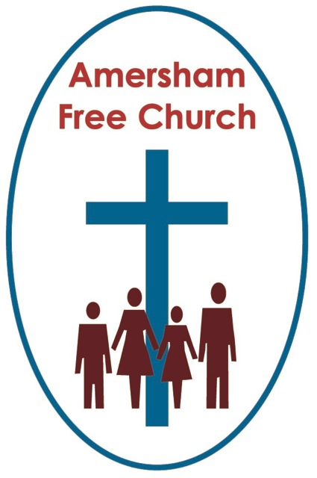
Isaiah 35.1-10
Matthew 11.2-11
15th December 2013 Advent 3

‘Are you the one?’

Lord God – in our Advent waiting we listen for your voice. So touch our minds and our hearts with your message of hope – we pray in the name of The Prince of Peace. Amen.
‘Are you the one?’ That was the question the languishing, imprisoned John the Baptist told his disciples to ask Jesus.
It’s a poignant question – in fact it sounds almost like a challenge. ‘Are you the one – or should we be expecting someone else?’
He sounds disappointed, confused and even a little miffed! After all hadn’t he given his all to the Overture – surely he’d played it well with that dramatic clothing, unusual diet and barn storming preaching. But now...it felt as if the moment had passed and the momentum faded. Days of bright expectation tuned into sepia disappointment.
Are you the one?
Of course we’ll have asked that question from time to time ourselves.
Is this the right name on the ballot paper? Can I put my cross against this politician?
Is she the one, or he the one I might give a ring to on a wedding day?
Is this the minister who might bring our Pastoral Vacancy to a close?
Is this the Christ I want to honour in my life day by day, and worship here alongside fellow disciples Sunday by Sunday?
Are you the one?
Now some New Testament commentators wonder if this was actually a bad question from John. That it might, even, have been the wrong question. Because, in a way, doesn’t Jesus dodge it? In not answering him directly is he sort of hinting – John, you’re asking the wrong question here – Jesus is questioning the question.
Well I’m not so sure I want to be that harsh on The Baptist. But what I do sense is that John, just like all of us, by simply asking the question showed us a great deal about himself. It is probably an understatement to say John had already ‘pre-defined’ his expectations when it came to the Messiah. Perhaps these aspirations were way off, too other worldly or spiritually dramatic. Whatever they were we get the sense that Jesus wasn’t coming up to scratch for John. Right now, in prison he’s frustrated and disappointed.
But this morning I suspect many of us feel John’s question might have been one that we would actually have asked. That it seems to us to be a natural and understandable one.
We know that John only just makes it into the story of Jesus – he’s much more there at the beginning than the end. He sees the genesis of this movement from within Judaism. He preaches like an Old Testament prophet and all his energy and longing is for the Messiah. And like many after him what he longs for and what he gets doesn’t always tie up.
Yet, at least, he is asking the question.
One of Rowan Williams’ final books as Archbishop of Canterbury was Faith in the Public Square. And in it he says that he doesn’t really believe people have actually rejected Christianity. Instead, he thinks, they have sort of parked it to one side – buying into a cultural mindset that says its day is over and its time has gone. So, Dr Williams concludes sadly, very few are actually asking questions any more about the story of the bible, the evolution of the church or the teachings of Christ.
But John was, and hopefully you are – and maybe, just maybe a friend or family member you know might be asking these questions too.
So how does Jesus answer John?

Next week we’ll be singing that line from O Little Town of Bethlehem that goes: The hopes and dreams of all the years are met in thee tonight.
So what was John’s dream for Jesus if he were really the Christ?
It’s a question we all have to ask from time to time because we can make God in our own image. John Hapgood, a former Archbishop of York put it like this: To believe only what you like, is to believe only in yourself.
Was that what John might have been doing – he’d already made up his mind what the Kingdom of God would look like and now Jesus would have to squeeze somewhere into the picture.
And on occasions we phrase our prayers in such a way that God has only one option in answering them. And when the answer doesn’t come our way we suffer a rather self-induced crisis of faith.
Jesus didn’t answer John’s question directly but takes Old Testament Messianic scriptures about the anointed one cleansing lepers, healing the lame and opening the eyes of the blind – and says – all of this is happening! John - The Kingdom is not some far off, other worldly dream – it’s among you in every act of healing, wholeness and kindness being offered in my name.
One of the gentler carols, written by Christina Rossetti, which we sometimes sing at this time of year goes:
Love came down at Christmas, love all lovely, love divine.
Perhaps – just perhaps – in all the longing for liberation, justice and new beginnings which our firebrand John held on to – love had been squeezed out. So Jesus puts it back - front and centre.
Some have suggested, rather tantalizingly, that this was like a potential conversion moment for John. Would he listen to the answer? Would he leave his ideas about Messiahship and embrace Christ’s exemplification of it? Or would his disciples and those of Christ’s go their own way and seek different paths to the truth?
We don’t know – for all too soon John’s part in the gospel narrative is snuffed out by a vain King Herod.
Are you the one?
I’m convinced that’s a necessary question that every seeker after truth will want to ask – and keep on asking. That’s because disappointments, frustrations and even disillusionments– are natural and honest experiences in any pilgrimage of faith.
I’ve forgotten who said this – perhaps someone will tell afterwards – that the gospel has to be continually forwarded to a new address.
So in my own life – I sort of woke up to faith in my early teens when I saw the world in youthful black and white. Looking back I hardly recognise the strident faith I expressed at my school C.U. or church youth group. Forty years later I’m a different version of me – and because I’ve been on a journey wouldn’t it be odd if my faith had stood still. It’s constantly having to be forwarded to a new address.
As I’ve said goodbye to my parents and welcomed my children, as I’ve left singleness and shared a life in marriage, as we’ve moved about the country – as I’ve read and prayed, laughed and cried – a valid question has always been: Are you the one?
Not the one who comes pre-packaged and manageable. But the God of surprises. The slow revealing God who seems to say that ‘waiting’, ‘pondering’ and ‘yearning’ are valid experiences on any spiritual journey.
The God who came at Bethlehem in the guise of a baby.
The God who spoke to us in the ‘unyielding grace’ of Nelson Mandela’s life of forgiveness.
The God who was so obviously at work in the gentle and loving care I saw being offered at Sycamore Club a fortnight ago.
The God I meet every time I’m on a hospital ward or at a nativity play.
And the God I see in the face of Jesus Christ.
Are you the one? Well you’ll have to make up your own mind.
But for me – well, I think he is. And if you ask me why?
I think I’d answer: Because – Love came down at Christmas.
In the name of The Father, Son and Holy Spirit Amen.

