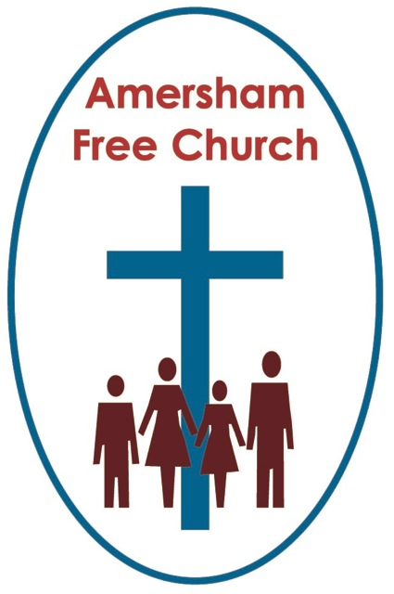
Isaiah 2.1-5
Matthew 24.36-44
1st December 2013

Keep Awake!

Lord God – our prayer is that the written word will point us to Christ, the Living Word – so in his name we pray and for his voice we listen. Amen.
An October Sunday this year and he was in church, just across the aisle from my pew. The sermon hadn’t even started so it wasn’t that. But for whatever reason he kept nodding off. The first few snores were easy to ignore. Indeed he woke himself up and us embarrassed church-goers in that central London congregation probably thought that was the end of it. But, oh no – two minutes later this soporific symphony of snoring recommenced getting embarrassingly louder and louder with every bar. People were starting to giggle so the steward thought the most loving thing was to give the man a healthy prod. This rude interruption from his slumbers seemed to do the trick and if not alert he did, at least, keep the eyelids open until the blessing.
Well if going to sleep in church does you good I’m not necessarily against it – but I’ve loved being able to entitle today’s sermon on Advent Sunday ‘Keep Awake’. A phrase taken directly from today’s gospel.
And those of you who are awake and on the ball will have noticed that as today is the start of a new Liturgical Year we’ve switched gospels from Luke to Matthew – from which most our sermons from today and into 2014 will come.
Well Advent is here - a time for us to anticipate and ponder with expectation the coming of Jesus and over the next few weeks we’ll do that in a spirit of joy and thanksgiving. It’s one more opportunity for us to affirm our belief not in a distant and stoic God but God among us, Immanuel.
Yet Advent isn’t just a time to re-imagine that first nativity at Bethlehem. Another theme brought to us by the compilers of the lectionary is that of Christ’s Second Advent. Much of today’s gospel reading you’ll find in Mark 13 – that was probably Matthew’s source – and coming where it does, Matthew makes these words part of Jesus’ last speech.
So here’s what he says in verse 42 of chapter 24: Keep awake, then, for you do not know on what day your Lord will come.
There are some who just love to do what Christ told us not to – that is predict a date or at least hint at a time for the so called ‘Second Coming’.
Why is that?
I wonder if it has something to do with a wish to be in control – because ‘not knowing’ is to face our vulnerability.
In recent days we have watched the people of the Philippines endure the devastation of Typhoon Haiyan – now thought to be their country’s deadliest natural disaster. With so much swept, literally from under their feet, with such a fragile and uncertain future now in store for thousands, there is an inevitable sense of intense human vulnerability – of not being in control.
Vulnerability is part of life, faith and indeed death. And at one level these gospel words stating that: not us, nor the angels, in fact not even Christ knows the time of this second coming – underlines this inevitable part of our humanity. There are many things we do not and cannot know. We are not always in control. And living by faith often means striving to live with that sense of deep trust in God – not the God who gives us all the answers, but the one who enables us, by his grace, to live with the questions.
And because the bible often connects up – all be it in poetic language – the idea that the Day of The Lord will follow a period of struggle, persecution or even natural disaster – it’s often been the case that those going through such calamities have decided their age was it – whether that was the Roman war against Israel in 66-70AD or the nightmare of WWI. These atrocities confirmed, so they said, that this Second Advent was now imminent.
And in a way I understand that. For although I’m more inclined to demythologise the idea of The Day of The Lord I think it’s perfectly understandable to think of it in terms of hope, relief and maybe even restitution.
After all I’ve never lived in the context of state persecution suffered because of my faith or conscience. I’ve never lived at a time when the threat of invasion hung in the air. Like you, perhaps, I have visited museums which commemorate the Holocaust, with us visitors growing quieter passing from one room to the other until coming to the final display where no- one could utter a single word. But none of us in church has actually experienced such grotesque brutality.
Perhaps if I had endured and suffered that way I would understand this poetic term ‘The Day of The Lord’ very differently. Matthew probably did, writing his gospel around 80 AD with the church no bigger than a few thousand battling against the oppression of Rome and the scepticism of the religious hierarchy. If that were my context maybe I too would revel in those Old Testament prophetic passages about the end times or the eschatological verses of the gospels, and perhaps the last book of the bible, Revelation, with its apocalyptic style, would be my favourite.
And in all this I would be sustained by the idea that evil won’t win, that brutality cannot triumph over love, that justice will prevail – and I would believe (as, indeed I do believe) that the future is God’s – and because of that although I may not get through those difficulties I hope I would still be able to trust in God, his love, his light, his hope and his day.
However, – spared as we mercifully are such horrors as the early Christians or contemporary Jews had to endure what are we to make of today’s text for Advent Sunday urging us to Keep Awake?
The opposite of such alertness is to be asleep. So from what are we being called to awake this Advent?
The story of Noah, quoted in the Matthew passage, gives us a clue. Isn’t the point here that everything seemed fine in that society – yet that’s not the way God saw it. For Noah’s neighbours had airbrushed God out of their lives. Centuries later it’s a characteristic we’re all too familiar with. Our own society at times seems obsessed with self, intoxicated by wealth and motivated by pleasure. And we in the church can fall victim to that way of thinking just as much as anyone else. At such times when we have become numbed to the call of God upon our lives there comes the call this Advent to Wake Up.
Maybe the whole message of the gospel has become too comfortable for us on our journey of faith. We leave Jesus in the cradle because we don’t know what to do with him upon the cross. We honour Mary as his mother without taking note of the radical manifesto for justice she sings in the Magnificat. We love the fellowship of Church but do not live out our baptismal vows in our weekday lives, or Isaiah calls it in today’s Old Testament Reading: To walk in The Light. At such times when we have become numbed to the challenge to be a pilgrim risk taker there comes the call this Advent to wake up.
Or perhaps we have simply forgotten that the Day of The Lord – his coming among us – is also to be experienced in our everyday routines as much as our times of worship, out in society as much as here in church. For as we have prayed this morning: Thy Kingdom come on earth as it is in heaven. Last month our Book Group looked at Stendle Rast’s Gratefulness – The Heart of Prayer. In which the author defines prayer as those moments when we sense, with gratitude, a spirit of connectedness between God and us, and us with each other. Precious moments which he defines as prayer. Enjoying togetherness around a meal table, going to our Parent And Toddler Group here Fun at One on a Friday afternoon and seeing the warm smiles on the faces of the parents encouraging their child to do a jigsaw, stick some shapes or dress up, or take a walk through leafy Bucks and breath in the beauty of late autumn. At such times when we have become numbed to the way faith and life connect – and that God is in it all - there comes the call this Advent to Wake Up.
Walking down Sycamore Road last week I passed Pizza Express with a poster in its window proclaiming ‘Christmas is here’. The pedantic cleric in me wanted to bang on the window shouting ‘No it’s not – don’t you know Advent comes first’. You’ll be glad to know I resisted this temptation!
But let’s not resist this call to Wake Up – and let’s use these next weeks of Advent as weeks of challenge - stirring us from an apathetic, familiar, watered-down, or disconnected and ungrateful sense of duty and choosing instead a committed, risk-taking, radical and grateful path of pilgrimage – one worthy of The Kingdom of God and The Day of The Lord.
May it be so, in the name of The Father, Son and Holy Spirit. Amen.

