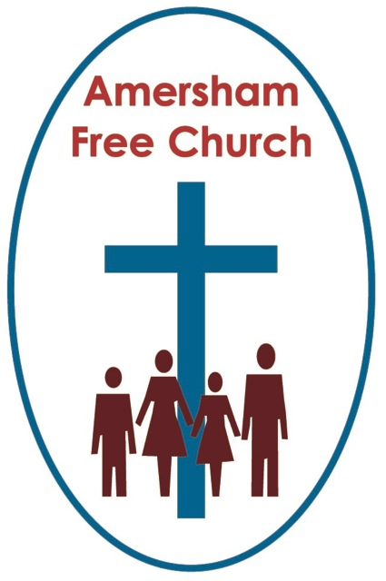
10th November 2013
Luke 20.27-38

Debating Heaven

Lord God – our prayer is that the written word will point us to Christ, the Living Word – so in his name we pray and for his voice we listen. Amen.
It’s sometimes said by those writing up the lives of politicians that they ‘campaign in poetry yet are forced to govern in prose’. Maybe that’s just a euphemistic attempt to justify pragmatism at the expense of conviction.
I wonder then, how we would describe Jesus during his days of campaigning for the Kingdom of God? There are times, I confess, when it feels to me as if he spoke in poetry leaving us to work through the details in prose about what it really means to be church!
Maybe this enigmatic come poetic style of Jesus’ struck you as today’s lectionary gospel was read.
The Sadducees come up with a very specific – and I think it has be said very silly – question about heaven. And maybe as the gospel was read today we wanted to hear Jesus answer that question head on. Yet he doesn’t. Once again he uses poetry not prose and at one level this was no answer at all.
Well that leaves us a bit of work to do – so let’s get to it!
These events in Luke 20 come from the opening days of what we call Holy Week. On Palm Sunday Jesus enters Jerusalem riding a donkey and coming in peace. It was a somewhat provocative entrance and in a way it mocked those usual grand military processions so loved by Roman commanders.
Although it will end in actions, since Sunday Holy Week has been full of words. Words, debates and quite feisty arguments.
Roy Jenkins, in his biography of Churchill says he liked his arguments over knives and forks. I can imagine that having a meal with the war time premier was never a relaxing experience.
Well maybe in true rabbinical style these last days in Jerusalem for Christ meant having one debate after another and in today’s reading it’s the turn of the Sadducees.
Actually in Luke’s gospel this is the one and only time they directly engage with Jesus.
Who are the players here?
The Sadducees are the ones asking the question. It was in this group that all the concentrated power of the temple lay. In Jewish society the Sadducees were high up the pecking order; they were aristocrats and considered to be highly cultured. They filled the priesthood and they did so with a highly conservative and reactionary mindset.
And although it’s always a little unfair to caricature a group for what they don’t believe in rather than for what they do - maybe the one thing that most of us know about the Sadducees is that they didn’t believe in the resurrection.
So in Luke 20 the good guys are in fact the Pharisees! They are portrayed by the evangelist as more open minded, liberal even. They embraced the idea of resurrection and indeed at this point in the gospel, as Luke portrayed Jesus as a Torah observant Jew - he is happy to side Jesus along with the Pharisees – to identify him, as it were, in their stream of thinking.
Now this debate about resurrection was really one about which biblical books each party believed to be authoritative.
For the Sadducees the Torah – God’s word and law – was exclusively to be discovered in the Pentateuch – that is the first five books of the bible. And surprise, surprise there’s no mention, or even poetic idea of resurrection in these writings.
Oh no! Say the Pharisees. That’s too narrow an understanding of authoritative biblical literature. We believe that God’s word was also spoken in the Psalms and the Prophets. Now that’s a much bigger canvass and at least the idea, the concept and the language of resurrection is to be found in these books.
We know too that this idea of an after-life filtered into northern Israel about 300BC from Persia.
And there was, perhaps, a reason why that idea took hold. Being a believer, indeed being a Jew, in Roman society wasn’t straightforward. For example Luke’s gospel, written around the year 100AD would have been read by those who had lived through the fierce destruction of Jerusalem and the Temple by the Romans in 70AD. These days of terror and religious persecution had felt like an injustice. So the idea that the righteous, especially those who had died for their faith, would be rewarded in the next life and that there would be sort of judgement after death, grew and developed in Jewish, Pharisaic thought.
Now the Sadducees were not averse to ridiculing those who believed in the resurrection and it’s probably the case that this wasn’t the first time they’d trotted out such a complex question to try and trip up anyone who advocated an afterlife.
The question they put to Jesus that day – about a widow marrying seven brothers one after the other – was also their way of playing the ‘Family Values’ card in this debate. For ultimately the family in Jewish society was its own welfare system. So phrasing the question this way, they probably thought, gave them the moral high ground.
But Jesus was having none of it.
So what are we to make of this rather strange encounter?
Well I think one issue that emerges from this conversation is that of language.
In our scientific age we want verifiable answers – and that includes answers about heaven. What’s it like? Who’s going to be there? Does it actually exist? Will I meet up with loved ones? And if I get there will I spend eternity as a young, middle-aged or old me? Such questions pose similar conundrums to the one asked that day by the Sadducees.

In today’s reading Jesus doesn’t answer any of those sorts of questions which may indeed disappoint us.
Instead Jesus deflates the Sadducees balloon somewhat by pointing out that one of the reasons for marriage here on earth – and this was especially true in his culture at that time – was to do with lineage. From marriages there were children, from children there was lineage, the name lived on, the family grew and supported each other and so there was security and permanence.
But, says Jesus, heaven is not to be thought of in these terms. For a start the woman in the posed question was thought of as property, first of brother number one through then to brother number seven. That’s not the way it will be in heaven.
So Jesus begins to use a different sort of language to describe us and heaven and says in verse 36 that we will be like the angels, we will be children of God.
I suspect I’m a bit of a Sadducee myself when it comes to heaven. By that I mean I don’t think about it too often and much of my belief system if I analysed it would, I think, be about God and neighbour in this life rather than storing up all my hopes and dreams for the one to come.
Yet I’ve never not believed in heaven – I just don’t think I can define it accurately or tie it down specifically. I think of it in terms of mystery – a new reality which this side of death I cannot and never will fully grasp.
This, I suggest is what Jesus was saying to the Sadducees in today’s gospel. Urging them to stop playing such a pedantic game in that pointless quest of using an earthly paradigm to describe a heavenly reality which has no equal in either the language or experience we know today.
But to leave it there would be, I think an utterly inadequate reflection on this reading – because Jesus doesn’t leave his hearers there.
Instead, to these Torah loving Sadducees, he cleverly quotes back to them a story from the Torah. He reminds them of Moses standing at the burning bush worshipping – reaching out to Yahweh and calling him the God of Abraham, Isaac and Jacob.
In one sense that could just be a role call from history, but put it together with the next verse: God is not God of the dead, but of the living: in his sight all are alive... and we begin to build up this picture of hope.
These patriarchs represent different generations yet they all found their ultimate confidence and security in God. It’s God who holds us all together, the church on earth and in heaven. God is at the centre of this Judaeo-Christian understanding of heaven – and as our life is touched by his – so there grows a hope within us – the hope of heaven.
So there is a hint in this story of Moses at the burning bush that he thinks of Abraham, Isaac and Jacob not as dead saints from yesterday but fellow worshippers very much alive with whom he units around Yahweh, praising God today.
In his lovely book critiquing the Narnia stories, The Lion’s Tale, Rowan Williams has this one liner: Death is profoundly serious – yet less than final.
That sense that there is a future beckoning us beyond the grave – not one we can scientifically analyse or specifically predict – but a future which Jesus says is like a room being lovingly prepared for us, is the reason why I wear a white stole at a funeral service – the colour of Easter – that season of hope, trusting in the love and grace of God.
I think it’s worth affirming that belief on a day such as this - Remembrance Sunday. I think it’s worth affirming that belief in a year when so many have died in Syria. And I think it’s worth affirming that belief during this season of All Saints when many of us will be carrying in our hearts the loss of someone we hold dear.
From today’s gospel Luke portrays a Christ who spoke of heaven.
And although no words we might use could ever fully describe it – it’s our faith in God – the God of yesterday, today and tomorrow – which keeps that whisper of hope alive in our hearts – a whisper than says with the former Archbishop: Death is profoundly serious – yet less than final.
May it be so for us and all whom we love, in the name of the Father, Son and Holy Spirit. Amen.
Ian Green Amersham 7th November 2013

