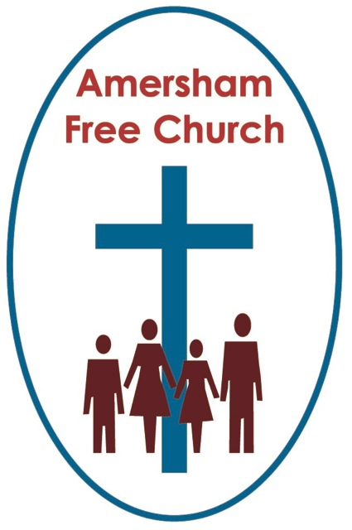
3rd October 2013
Luke 19.1-10

Zacchaeus the Tax Collector

Lord God – our prayer is that the written word will point us to Christ, the Living Word – so in his name we pray and for his voice we listen. Amen.
This morning the lectionary gives us this transformative encounter between Christ and Zacchaeus - a first century chief executive from the Inland Revenue. His story isn’t one found in all four gospels, just Luke’s and in it he’s made into something of a minor hero – indeed some commentators say it forms a fitting climax to Jesus’ ministry. It also echoes (and Luke likes that literary technique) the call of Levi in chapter five. Both, we note have a conversion with a financial theme.
However, I suspect his contemporaries, the other inhabitants of Jericho, would be horrified by the thought that over the centuries Zacchaues, a vertically challenged civil servant, has become their most famous citizen.

It’s sometimes pointed out that this meeting between Christ and a Tax Collector contains St Luke’s three favourite themes, and here they are: Istly the problems that come through wealth, 2ndly the tendency of Jesus to associate with sinners, and 3rdly the growing realisation by many that Jesus was the Christ.
Or put it another way, today’s story is yet one more example of a three way tension that often crops up in Luke’s narrative. There is Jesus, someone he befriends and thirdly, always a critic in the background tut tutting!
So this morning let’s work our way through what is for many a very familiar bible story.

Luke 19.1: Jesus entered Jericho and was passing through.

He was on his way to Jerusalem – this was his final journey to the cross and Jericho his final stage. Jericho had the best of reputations and had been given the name: ‘City of Palms’. The historian Josephus calls it a ‘divine region’.

A few years ago we spent an evening at Saint Tropez – I realise I’m just showing off in the sermon now. It was only 20 miles from our campsite, but such was the crush of traffic during that high summer season, that it took us 2 hours to get there. Saint Tropez is no more really than a small fishing town on the Mediterranean, but its harbour was crammed full of ocean going yachts. We gazed at the rich eating their supper on these gleaming boats as we tucked into our cheap ice creams. We even bought a fridge magnet to say we’d been there – but I have no desire to return.

How can I put it? There was something almost numbing to be surrounded by so much ostentatious wealth. It was as if nothing was actually real – or did I feel that way simply because I was one side of the gangway and the yacht owners were the other?!
I’m not suggesting Jericho was the Saint Tropez of Palestine – but it was a rich place. And that’s why a chief tax collector could do well in Jericho.

Now did you notice this encounter happened simply as Jesus was ‘passing through’. This meeting wasn’t planned. Read the gospels and you don’t get the impression that Jesus lived by an appointments diary – which is a bit of a challenge to those of us who do. At least He didn’t have such a detailed prearranged schedule that he couldn’t fit Zacchaeus in until next Tuesday at 3.45.

Much of Jesus’ ministry, it seems to me was surprisingly ‘reactive’. That is he responds to the situations around him. Each day was an adventure. Who would he meet? What conversations would he have? I’m sure the disciples didn’t know. But they knew this – Jesus would surprise them by making time for the most unexpected encounter.

Churches are, understandably, often helpfully driven by pre-planned activities. We have our programmes and meetings entered in our diaries. And that’s good because it represents real commitment. But we should never devalue the spontaneous.

In the end we all realise that some of our best work can be done whilst ‘passing through’. The chance conversation. The unplanned encounter. Making time to grasp that unscheduled opportunity.

After all it’s about living out our faith – and when the moment comes – whenever and however it comes – making the most of it – for Christ’s sake.

That’s the way he lived. Jesus entered Jericho and was passing through.
Now what about Zacchaeus - Verse 3: He wanted to see who Jesus was, but being a short man he could not, because of the crowd…

Obviously this crowd was large and we can picture the scene in our minds eye with all the noise, jostling and dust.

Jesus didn’t always enjoy or encourage large crowds. Early in his ministry he told people to keep news of their healings to themselves rather than spread it around. He knew that being ‘famous’ might hinder his message and that big crowds are often full of people who come for the thrill of spectacle rather than to listen to what he had to say.

But by now, on this last leg of his journey to Jerusalem the momentum had built and the crowds – like this one in Jericho - were unstoppable.

Zacchaeus would have had few friends in this crowd but many enemies. I suspect he didn’t get out much socially. So he must have been very determined on this occasion.

And it could perhaps be justifiably argued that many in the crowd that day would have reason to push him, thump him or quietly dig him in the ribs as he went by. He had overtaxed them, cheated them – call it what you will it felt like daylight robbery.

Imagine, then, the crowd’s response as Jesus approaches this sycamore fig tree – verse 5: Zacchaeus come down immediately, I must stay at your house tonight…

It seemed so wrong of Jesus, so insensitive - like inviting Robert Maxwell to the Pensioners Party. Zacchaeus was the enemy of the people. To these wronged clients of his Jesus had simply lost the plot. Verse 7: All the people saw this and began to mutter, He has gone to be the guest of a sinner…

Maybe you and I would have sidestepped this appointment. Too controversial and outside our comfort zone.

But Jesus meets the very sort of people we might try to avoid. In religious terms Zacchaeus was actually on the margins, the edge of respectability. Yet it was often these people who responded to Christ best.

So what was his reaction? Verse 6: So he came down at once and welcomed him gladly…

That one verse says so much – Zacchaeus welcomes Jesus. The same could not be said for the religious hierarchy of the High Priests, Scribes and Pharisees.

What follows next is the wonderful drama of conversion. And to show the integrity of that change of heart St Luke doesn’t give us a baptism, or a religious service. He doesn’t put fine sounding liturgical words into Zacchaeus’ mouth. No. Instead he gives us Repentance followed by Restoration.
Bill Loader, the Australian commentator puts it like this as he ponders why Luke recorded this incident in the way he did saying: Did he, too, have many Christians in mind who see salvation as a ticket to heaven or as a recipe for inner tranquillity with little or no thought for social justice, for distribution of resources, and especially for the poor?

To show just how genuine his conversation was Zacchaeus says, verse 8: Look Lord! Here and now I give half of my possessions to the poor, and if I have cheated anybody out of anything (that was probably the understatement of the year in Jericho!), I will pay back four times the amount.

William Barclay tells the story of a Victorian women listening to three other women tell their testimony in a mission hall service. She is unmoved and angry at what she hears, because all three owed her money and could pay but hadn’t – so she and her family went hungry. You see quite simply their testimony didn’t match their actions.

James was to take up that theme in his letter – that faith without deeds is dead.

For Zacchaeus meeting Jesus changed his life and his life style. He was both poorer and richer because Jesus had come into his life. Financially speaking Zacchaeus was now in significantly reduced circumstances. Spiritually speaking he comes across as a man now at peace – peace with God and for the first time in his working life, at peace with his neighbours in Jericho.

This was a repentance that wasn’t just personal it was essentially social.

I learnt this story of a taxman up a tree at Sunday School – I even remember the song we sang all about Zacchaeus being a very little man.
Yet the truth is we have to keep on re- learning the story – that the faith we express here Sunday by Sunday in our hymns and prayers needs to be the motivation and inspiration for all our weekday challenges. That what we might call salvation or conversion has an intrinsic social consequence to do with justice and peace.
May that be our desire and our experience this week, in the name of The Father, Son and Holy Spirit. Amen.
Ian Green Amersham 24th October 2013

