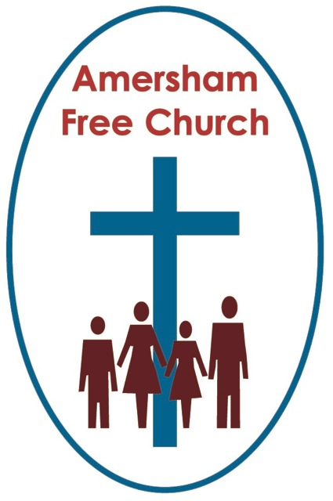
5th May 2013 Easter 6 Year C
Acts 16.9-16

Lydia’s Story of Life and Faith

In his autobiography former President, Bill Clinton writes:
I learned a lot from the stories my uncle, aunts, and grandparents told me: that no one is perfect but most people are good; that people can’t be judged only by their worst or weakest moments; that harsh judgements can make hypocrites of us all; that a lot of life is just showing up and hanging on; that laughter is often the best, and sometimes the only, response to pain. Perhaps most important, I learned that everyone has a story – of dreams and nightmares, hopes and heartache, love and loss, courage and fear, sacrifice and selfishness. All my life I’ve been interested in other people’s stories.
Of course all of us have a story. My grandfather, in his retirement days, read a book a week from his local library. Every Tuesday he’d return one and check out another and my grandmother used to get so frustrated with him because every book, every week was a biography. ‘That’s all he ever reads’, she used to say – well why not!
During these weeks of the Easter season the lectionary has been taking us on a journey of stories. The story of people becoming the friends, disciples and followers of the Risen Christ. These are stories of encounter, hope and transformation. And we in 2013 are part of that continuing story.
Today in Acts 16 we meet a lady who is sometimes described as the very first European convert, Lydia of Thyatira.
We come across Lydia at a Prayer Meeting.
Paul has had a vision urging him to travel further west into Macedonia. This region was the birthplace of that empire builder Alexander the Great, and this leading city of Philippi – the location of Lydia’s Prayer Meeting, was named after Philip, Alexander’s father.
There is, I think, something exciting about this city. It’s a Roman colony, a place of trade being near the sea port of Neapolis, it had a Jewish community – hence the Sabbath gathering of prayer by the riverside and soon it would be home to a new church – which, according to the New Testament letter we call Philippians, it was a church, and this wasn’t always the case, that Paul was deeply thankful for.
So, by the river Lydia and some other women gather together to pray. Maybe there were insufficient worshippers to form a Synagogue – we don’t know. We just piece together the jigsaw puzzle and what emerges is a picture of quiet faith, supportive prayer and an openness of spirit.
Verse 13 says: On the Sabbath we went outside the city gate by the riverside where we thought there would be a place of prayer; we sat down and talked to the women who had gathered there.
There is a gentleness about Paul at Philippi which is intriguing. This isn’t the strident preacher but the courteous rabbis sitting down by the riverbank one Sabbath and talking – simply talking - about faith with the women who had come to pray.
Prayer was part of Lydia’s story.
Last Sunday I was interested to see on Songs of Praise that the newly refurbished nave in Wakefield Cathedral has a Labyrinth. This maze like pattern on the floor helps people walk prayerfully. And in walking to a central point and then walking quietly away from it many find a sense of God walking with them. I was heartened to hear two Yorkshire men say how much the Cathedral Prayer Labyrinth had helped them think about their journey with God.
We all pray in different ways. At its most basic prayer is about being open to God.
It was part of Lydia’s story.
And so was work. Prayer and work are not mutually exclusive or simply the preserve of those who wear clerical collars!
In a day when the story of women’s contribution to society often went shamefully unrecorded there’s a sense of real value given to Lydia as Luke describes her as a seller of purple cloth. Perhaps she was the Anita Roddick or Martha Lane Fox of her day – a businesswoman – someone whose trade was about harvesting the expensive dye from shellfish and then making beautiful clothes with her purple style signature.
As Luke describes her so we get a fuller picture of her life – something of the whole person and that connection between the life of prayer and the life of work.
One of my ministerial colleagues was due for a sabbatical and I asked him what he would be getting up to during his time away from the pulpit. I thought he might be going on a retreat and attending a couple of conferences – no – he said, I’m going to work as a volunteer porter in my local hospital – I want to feel again what it feels like to go out to work.
Well – my sons frequently tell me I only work one day a week – but I’m not sure my friend necessarily felt that – he just wanted to use his sabbatical to identify more with his congregation in this world of work.
I struggle with how we might do that more in church. Perhaps we’ve had enough of the office or the shop and on a Sunday we’re glad to be somewhere different and wouldn’t appreciate being reminded of it. And what do pulpit references to work mean to a congregation in which many are retired – and yet have never been busier!
But we ought not to give up the struggle of making that connection in our stories.
We’re told the Celtic Christians who lived and worshipped on these islands long before the missionaries from Rome arrived always saw prayer and work as an indistinguishable whole. Prayers were said as cows were milked and wood chopped just as much as on a Sunday in church.
Prayer and work were part of Lydia’s story.
Baptism became the next chapter of her biography. Lydia joins that small New Testament group whose baptisms were recorded; these new disciples included Paul, the Philippian Jailer and the Ethiopean Finance Minister.
These baptisms were all signs of an inner faith. Verse 14 describes the spiritual stirrings of the heart Lydia was going through: she was a worshipper of God and the Lord opened her heart to respond to what Paul had said. She was baptised...
There are times in life when words by themselves seem inadequate so we mix them with symbols to heighten the moment. At a wedding, for example, we exchange rings.
I recently watched that intensely moving film starring Martin Sheen called The Way. Four, in one sense, highly incompatible and unlikely pilgrims walk the Way of St James to Cathedral of Santiago de Compostela in Galicia, Spain. Diana, the Vicar of St Michael’s here in Amersham, did part of that walk with Ray her husband during her recent sabbatical.
At the end of their walk the Dutch pilgrim from the group – a weed smoking pilgrim with little religious background – is so overcome by his experience that quietly, whilst no one is watching, he sinks to his knees in the Cathedral before the statue of St James. There was something deeply moving and powerful in that scene. Falling on one’s knees doesn’t sound a big deal yet we were left in no doubt that for Joost, this over weight Dutchman, it kind of meant everything.
In our sophisticated day and age of anonymous digital technology and fast communication I believe the signs, sacraments and symbols of our faith remain an invaluable gift to us. When we bow our heads in prayer, receive bread and wine, sit quietly before the cross in church or bring our children or ourselves for baptism – are we not in some small way saying with Lydia: the Lord has opened my heart.
And finally this morning I just note that hospitality was part of her story.
Straightaway she welcomed Paul into her home.
She seems to instinctively connect faith with community. So after her baptism what is more natural than to share hospitality with Paul; to be welcoming, generous and encouraging.
Since arriving here in October I’ve noticed that this church does a lot of eating together – something also noted by my bathroom scales!
Working at hospitality is a long term but priority project for every congregation. And of course it’s more than just food. It’s about the depth of our welcome, the consistency of our friendship, the faithfulness of our prayers and our willingness to travel alongside each other in grace even on rocky roads.
These are the characteristics we need if we want to continue living out the ideal of being a ‘Community for the Community’.
Today we have met up with Lydia, the seller of purple cloth and shared some of her story – a story of prayer, work, baptism and hospitality.
We all have a story. And may we sense God at work in ours – in the name of The Father, The Son and The Holy Spirit. Amen.
Ian Green Amersham 4th May 2013

