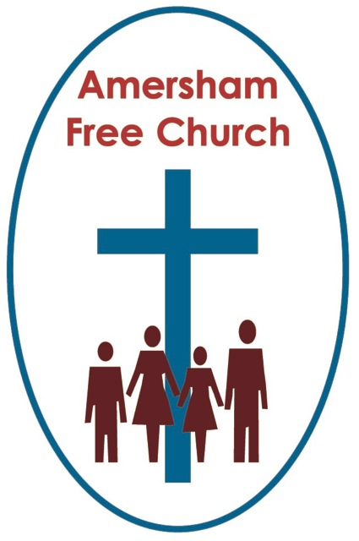
28th April 2013
Easter 5 Year C
Acts 11.1-18
Rev 21.1-6

A Broader View

We in the church, I think, genuinely work hard at being welcoming – but it’s a struggle and we don’t always get it right.
The other day one of our elders sent me this welcome statement from a church notice sheet. It is obviously fictitious yet it contains some phrases and sentiments that come perilously close to being fact. It reads like this:
Here at St Daphne's, we are a friendly church. Try not to be too scared by the smiles on our faces as we greet you.

Please be aware when choosing your seat that certain pews are designated to their regular occupants. You will have no way of knowing which these are, but be assured that they're definitely the ones you're thinking of sitting in. But although a bit set in our ways, we are a group of very welcoming people.
St Daphne's is dedicated to being a welcoming place. That's why we won't rush up to you on your first day, asking if you're any good at DIY or bell-ringing, or interested in singing in the choir. Oh no. But we will do so next week, of course. And see the checklist on the back of this leaflet, which you can use to indicate the various skills you may be able to offer. Especially roofers. We really do need someone who's good at roof maintenance.
St Daphne's is a Fairtrade church. Just as soon as we've got some power and running water, we're even hoping to buy some coffee.

And don't forget - the thing we need above all is money. That's why the envelope this leaflet came in contains a gift-aid form, a standing order form, the text of the Rich Young Ruler and a comedy picture of a sad vicar looking at a church with no roof on.

What’s the answer?
Sometimes I hear people say it would be so much better if we were like the Early Church, the Body of Christ as described in those exciting days of The Acts of The Apostles.
Well this may be a little too much like looking at church history through rose tinted glasses.
That’s because those early days of the Christian church although containing momentum as new congregations became established around the Roman Empire also saw deep power struggles, personal bickering and theological disputes.
Perhaps we shouldn’t be surprised about that as most of the really big and valuable things in life are worth struggle, effort and even disputation.
So what was the issue being hotly debated in this part of Acts?
The issue was ‘Inclusivity’ – the sort of welcome you might give to people who were not quite like you. At its most basic level a rift was opening up between the Christians at HQ – that’s the Jerusalem church – and travelling preachers like Paul and Peter who were working with new congregations who didn’t have a similar religious culture to them.
The believers at Jerusalem were struggling to move on in their understanding of faith. It’s not difficult to appreciate their situation because after all they lived at the very epicentre of their tradition, they came from family backgrounds that would have been very specific about certain faith practices; in fact some of them were even insisting that when Gentile men became Christians they should go through the old religious tradition of circumcision.
In all of this was the idea that God’s love should be ring fenced. It was more specific than inclusive. It was for a specific people – i.e. them! - , living in a specific geographical location abiding by specific traditions.
Now, just maybe, none of this really had anything to do with faith. It might just have been about heavy cultural indoctrination. The sort of mindset that says ‘We’ve always done it this way’ and simply cannot see there could possibly be an alternative which was valid.
We often get them blurred – issues of faith and expressions of culture – we often get them blurred and sometimes we can’t work out what’s really important.
Now, into this tense stand- off enters courageous Peter. He’s seen for himself how God’s love has touched hundreds of people with a very different religious and cultural background to his own. In the vision he receives in today’s reading God has made it clear to him that religious rituals – even food laws - can change, especially when we realise they are never ever big enough to hold the complete truth about God.
It’s like it says in the verse of an old hymn: But we make his love too narrow with false limits of our own, and we magnify his strictness with a zeal he will not own.
In the previous chapter to this morning’s Acts reading Peter had got to know a deeply spiritual and devout Italian soldier called Cornelius. This meeting changed Peter’s life. As he got to know Cornelius, who hadn’t been brought up in Peter’s faith tradition, he realised he was having fellowship with a true believer and a seeker after truth. At that point Peter grasped something important about God’s inclusivity and welcome and this is what he says in Acts 10.34: I now understand how true it is that God has no favourites.

Later in that chapter a whole group of Cornelius’ friends become Christians underlining for Peter that God wasn’t just working in Jerusalem but further north in places like Joppa too.
When I was in Sunday School we used to sing Jesus’ love is very wonderful. Never devalue the theology passed on to children at an early age by the songs we teach them. How did it go?
Jesus’ love is very wonderful,
So high – you can’t get over it.
So low – you can’t get under it.
So wide – you can’t get round it.
O wonderful love.
You see I even remember the actions!
That’s what Peter wakes up to in this part of Acts – the breadth of God’s love, its welcome and inclusivity.
Now all of this just begs a few questions about how we might keep up with God. Peter was finding that quite a task – around every corner God seemed to be challenging him with fresh truths.
So how does our faith grow? How is our belief challenged and deepened?
There’s nothing prescriptive about this but many of us have probably found four things of particular help on our pilgrimage.
There’s Scripture. By reading – especially the stories of Jesus in the gospels.
There’s Reason. Think it through on a walk; discuss it at a Life and Faith Group.
There’s Tradition. We learn from those who have gone before and shaped our church’s life and liturgy.
And there’s Experience. After all the words and discussions there comes a moment for many of us when we feel the need to worship God, to receive communion, to be baptised, to say a prayer – and in these spiritual experiences there seems to be a meaningful connection between heaven and earth. – moments of growth on our spiritual journey.
You see the question is never just: How much do we know about God? It’s essentially: How can I grow with God?
Many parents have the experience of their rising 5 year old coming back from the first day in Reception Class and saying in a rather triumphant way: Well that went well – I’ve been to school now – do I have to go again tomorrow!
Being a Christian isn’t about an event –a one off never to be repeated moment even if we call it ‘conversion’ - it’s a process. The process of discipleship – or we might use the term ‘apprenticeship’ - of being open, as Peter was, of grasping yet again how vast and all encompassing is the love of God.
For Peter, of course, such openness (even if grudgingly given at first) meant change.
We know change is tough because we feel threatened, especially when our core values seem to be questioned or devalued. And change is never neutral; it can be for the worse as much for the better.
The task we have is to discern the whisper of God in the challenge of change. Is God
asking me to think about this or that issue differently? Am I blocking new possibilities that might just bring about peace, reconciliation or new life because I’m stuck in my old prejudices and I need the courage to let them go? Have I bought into the myth that I’ve arrived, life will have no more challenges or surprises instead of realising that whatever my age there are still new and worthwhile discoveries to be made.
Peter could be the Patron Saint of many causes – we love him for putting his foot in it and speaking often before thinking – but might he also take up the title Patron Saint of those who have the courage to change their mind – because they are open to God.
We in the church shouldn’t claim that we are better at this than anyone else. We are a mixed bag. Take slavery.
For years British Christians supported the Slave Trade because it was part of our cultural DNA. Cities like Liverpool and Bristol built fine churches out of the proceeds of this trade. But gradually church leaders like Wilberforce and John Newton changed their minds and spearheaded the abolitionist movement. William Knibb from Kettering, a Baptist Missionary on the island of Jamaica, campaigned for this freedom so much that fellow Christians on the island who owned slaves called him ‘The Monster’.
Or take ordained ministry.
For years Christians of almost all denominations believed the ministry of Word and Sacrament should be the exclusive preserve of men. Yet the story of the second half of the twentieth century is of the church catching up with the rest of society and beginning to affirm the joys of equality in Christ and that servant leadership in God’s church is enhanced by women and men sharing that calling together.
My friends be inspired by Peter this morning. He is a very human disciple rather than a cut glass saint. He wavers, as we all do, from time to time. At one moment his devotion to Jesus knew no bounds, at another he is less than committed. Even on this issue of inclusivity he wobbled and at times was less enthusiastic about it than Paul. Yet here in Acts 11 he has the grace and humility, the openness of spirit to listen to God and reassess his prejudices. And for this moment in the unfolding story of the church we are grateful. A moment that proclaims just how much bigger is the purposes and grace of God than all our strategies and cultural limitations.
May we all have the gift of such moments – moments that both challenge and encourage us to be open to God and take the broader view.
May it be so in the name of the Father, the Son and the Holy Spirit. Amen.
Ian Green Amersham 25th April 2013

