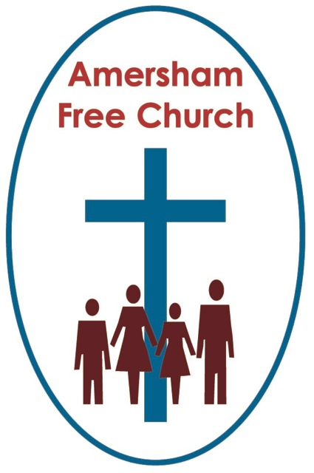
Easter Day Communion
and Jamie’s Baptism
31st March 2013

The Stone, The Water,
The Bread and The Wine

The Victorian author, one Anthony Trollop, based his novels on the lives of bishops, deans and clergy and their comings and goings in the Cathedral Close at Barchester. For all that he once said: There is no greater hardship inflicted on mankind in civilised countries than the necessity of listening to sermons! Now if you agree with him just keep it to yourself.

Well I have to say that for me one of the best days to be in a pulpit, preaching a sermon is Easter Sunday. A day to affirm our faith in life rather than death, in light rather than darkness, in goodness rather than evil. A day to proclaim our faith in a risen Saviour and living Lord.

So here’s my text for Easter Day 2013: Luke 24.2: They found the stone rolled away from the tomb…

What about that stone?

As the long day closed on Good Friday they took Jesus down from the cross. He was not a wealthy man so he had not put down a deposit for his funeral. Indeed he had no funeral at all; instead his body was lovingly taken away to the tomb of Joseph of Arimathea.

So it seemed to be all over. Rolling a stone in front of the grave was like coming to the final paragraph of a much enjoyed book, you close the cover, the end, finis, it’s over. On Good Friday this stone was placed at the entrance to the tomb and the credits rolled.

I remember visiting the large and lofty Parish church at Saffron Walden. Outside we wondered through the graveyard and of course saw many stones, each one representing lives that we hope were well lived but now extinguished. To our surprise we came upon the grave of RAB Butler, in his day a headline politician. On his stone they’d chiselled some of his many accolades: Knight of The Garter, Companion of Honour; but just like the humblest grave around that church, his headstone carried the same message that life, at least his life here on earth, had come to an end.

Well that’s what the stone represented to the disciples on Friday night.

Now it would have been heavy, probably the size of a cartwheel, slotted into a grove so that it could be slid into place. It covered the entrance to what was basically a cave, that was the Jewish custom, and in the cave there was a shelf upon which the body would have been placed having first been wrapped in bands of linen.

So the sun went down, and the next day was Saturday, the Sabbath, and there is silence in the garden. The disciples mourn and the shock sinks in.

But our text this morning, for them, was more shocking still – They found the stone rolled away from the tomb.

Their first thought was that grave robbers had been at work; indeed the authorities insisted on peddling that theory. It was either burglary or resurrection.

I believe in the resurrection of Jesus Christ and I love what Archbishop Michael Ramsey once said. In the late 60’s, early 70’s the media had yet to coin the term ‘sound bite’, even so the Archbishop came up with an excellent one by saying: No resurrection – No Christianity.

The Old Testament leads up to the cross and empty tomb, the New Testament is a celebration of all it means.

The cross shows us the love of God, dying to forgive us our sins. The empty tomb proclaims a great hope. Jesus has conquered the power of death and offers his new life to us.

If you do away with the resurrection then, at best, you turn Jesus Christ into an inspirational martyr or a well thought of role model, but if you take on board the resurrection he becomes a living Saviour and a personal Lord. You move on from mere respect to heartfelt worship.

So today I want to join with the millions of my brothers and sisters throughout the world and say; The stone was rolled away, not burglary but resurrection.

In light of all this as well as listening to a sermon at today’s morning worship we have also shared in Jamie’s baptism and in a few moments we’ll celebrate Communion. What’s the link?

Well in the first years of the Christian church Easter Day was always celebrated with baptisms. The candidates would go on retreat a few days before and then as the sun rose on Easter Sunday they would emerge, dressed in white ready to make their confession in words and action that Jesus Christ was Lord.

St Paul is the New Testament theologian who gives depth to the theology around believer’s baptism and he likens it to dying to self and rising in Christ. Once we’ve made that public confession in baptism that idea – dead to self, alive to Christ, becomes a daily challenge for all of us who take the Lordship of Jesus seriously.

The Resurrection proclaimed a new beginning. Baptism also signifies that fresh start. Hope, offered to us by Jesus and lived out by his followers, is a core theme in Christianity. Jamie, baptism for you we pray, won’t ever be seen as the end of your spiritual journey – but a marker on the way. That moment when you made a wonderful public statement that the hope offered to us by Jesus Christ goes deep with you.

Can I tell you of an early church tradition – at first it might seem a little macabre – but I think it rather special. Those early followers of our Lord were often buried in their baptismal robes, in graves facing east, pointing towards the rising sun. And all of that symbolised their belief that death was not the end – there is a resurrection.

Today, as Easter Morning people, we rejoice wherever we see and meet hope. A few weeks ago a group in our church made cakes for Red Nose Day. Comic Relief this year raised over 75 million pounds. I enjoyed watching it on BBC that Friday night not just for the wonderful Vicar of Dibley sketch but also for the inspiring updates on Vaccination Programmes and for the way that the One Direction pop group were so moved by the poverty and need they witnessed in places like Uganda – themselves inspiring a younger generation towards a more compassionate view of life.
We could cite so many examples – thankfully both inside and outside the church, for God’s kingdom has far horizons – of the way hope, offered through human hands – brings God’s Shalom, his joy and wholeness to our fragile world.
Wherever and whenever we experience hope I believe we are sensing something of the resurrection presence of Christ.

This day of resurrection reminds us of the new beginnings symbolised in our baptism and the theme of hope that’s so central to our celebration today.

And then there’s Communion.

My guess is that on Maundy Thursday our mind went to the Upper Room. But on Easter Day as we take bread and drink wine perhaps our minds are drawn to the Emmaus disciples meeting their risen Lord or to the fishermen apostles meeting Jesus around a breakfast meal by Galilee in those days between the resurrection and ascension.

Communion is many things, and one of the most important is the idea that here we meet with the risen Christ. What better a way to do it than in the manner he instituted, around a table, gathered with other seekers after truth, sharing bread and wine.

For this is a Eucharist, a time to give thanks. The cross was not the end – there was an empty tomb, life triumphed over death – so we are bold to say: Christ has died, Christ is risen. And every Sunday is for us a celebration of the resurrection as is every communion.

The stone was rolled away – that’s the discovery made by the disciples that first Easter Day. At first it filled them with dread, but as the day wore on, as the meetings with the mystery gardener or the enigmatic traveller to Emmaus took place, so a growing joy and hope filled the veins of Jesus’ followers. It is the same joy and hope that fills our worship today.

I must close. There was, as many of you know, a great preacher in central London, a Methodist Minister called William Sangster, he preached to hundreds in Central Hall just opposite Westminster Abbey. He loved Easter more than any other of the Christian festivals. Towards the end of his life he became paralysed and speechless. He was asked one day what he valued most about his ministry, was it that full church, it’s central London location – none of that - and with a twinkle in his eye he wrote on a piece of paper: The most precious thing for me was being able to proclaim on Easter Day, Christ is Risen, Alleluia.

