Tempted, tested and tried
Deuteronomy 26:1-11, Luke 4:1-13

17 February 2013
It is quite telling to look at different artists’ impressions of Jesus’ temptations in the wilderness. You have heard me on the subject of the Holy Spirit acting through the arts before. Suffice it to say here that I believe art can be the result of divine inspiration and therefore it is capable of mediating the sacred to us in the same way as written or spoken word or music, or silence can. Artistic interpretation may challenge our well-used assumptions and it may help us to arrive at new insights. So today, on this first Sunday in Lent, having heard the Scripture reading about Jesus in the desert, we shall be looking at some pictures. Instead of me preaching to you or at you in the accepted sense, what I am proposing to do is just look at these pictures with you and tell you what I find interesting in them. Hopefully, this will give you the chance to decide, and maybe tell me afterwards, whether they spoke to you in the same way, or led you into some other, different direction. As we get into this we may need a bit of a health-warning: consciously or unconsciously we all have some kind of pictorial image of Jesus in our heads and it will help if for the duration we could suspend that image. This is not easy, I know, but maybe the order of the pictures will help us with the transition.

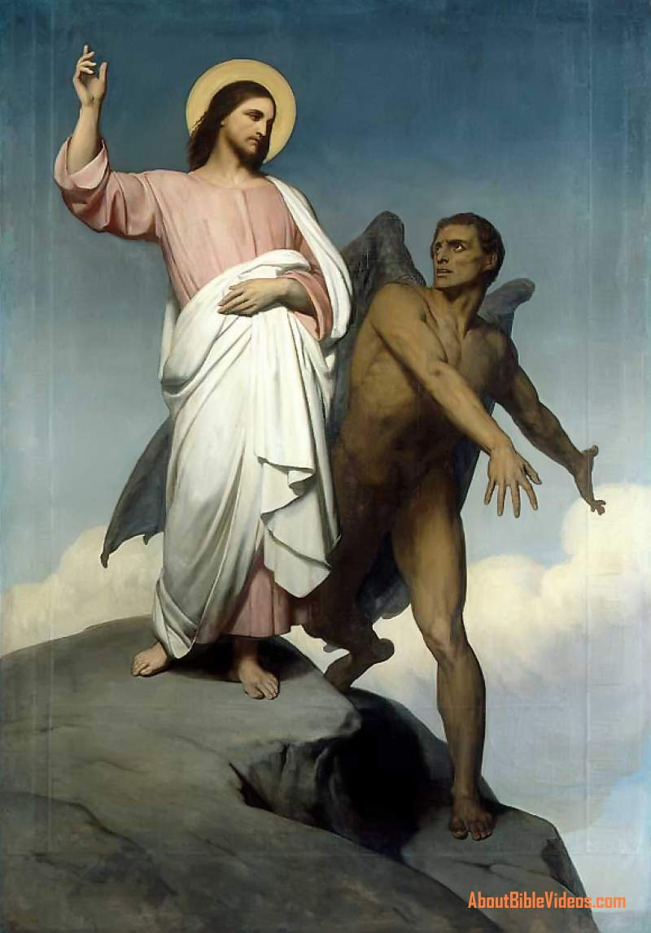
On our first slide we see a very traditional way of telling the story. Our well-trained 21st century eyes will know straight away how to form our first impressions. We have learnt from watching films or TV productions, how to decide who is the ‘goodie’ and who is the ‘baddie’ in a plot. The Franco-Dutch artist, Ary Scheffer, who painted the picture in 1854, very helpfully gives us all the clues in the same way. The Tempter is the robust, dark figure on the right; Jesus is clothed in white and also has a halo around his head. The moment which is caught is just after the devil has taken Jesus to a height and offered him dominion over all the kingdoms of the world. The usual interpretation of this offer is that it is a lie because Satan does not have dominion over the world and therefore cannot offer it to anyone. But if we think for a moment we realise that this is a visual temptation, Jesus is shown the physical, the material world and what is at stake here is whether he can be pinned down to the everyday realities of life. In this sense Satan is not lying, because if we believe in the exclusive importance of the material reality, we do find ourselves in the Tempter’s dominion. Looking at Jesus’ face we see a very certain, very serene expression with no sign of even a shadow of a doubt. And where there is no shadow of a doubt, there is no real temptation. This may be a beautiful picture (and it is a beautifully painted, well-proportioned, satisfying painting) but is it a true picture of the temptation, I wonder?

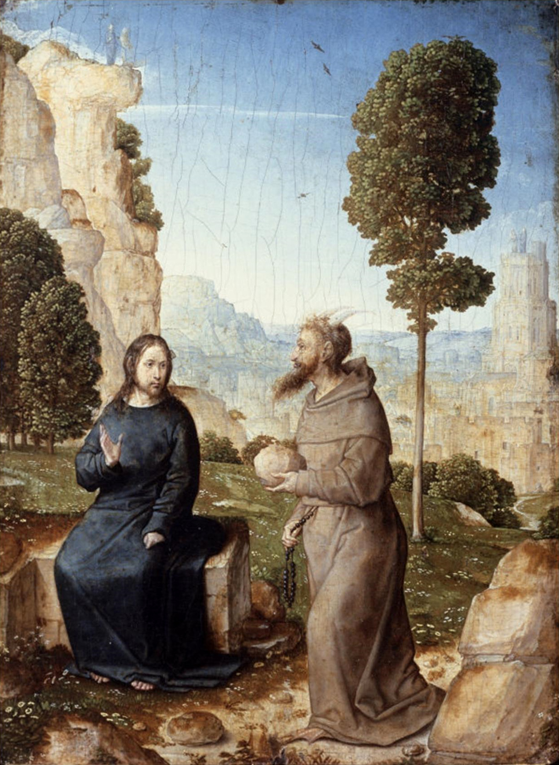
The second slide comes from the 15th century and was painted by the Spanish artist Juan de Flades and it was believed to have been painted as an altar picture for the Queen. I wonder what do you find most striking about it? Well, apart from the almost domestic atmosphere, I was taken aback by the clothing of the Tempter. It is a monk’s habit. If it weren’t for the two little horns on the head of the devil, we wouldn’t know it was the devil. And his facial expressions do not help us either. He looks almost benevolent, someone, who is looking after the hungry souls with great sympathy. What is this artist trying to tell us? That temptations may come from inside the Church, by way of the institutions of the Church? Surely not! But it makes you think, doesn’t it?
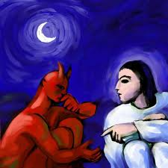
This next picture is my favourite, I think, even though I could not discover very much about its creator. Despite its highly stylized, modern portrayal of the temptation it has an intimate feeling about it. The startling presence of the moon indicates a night time encounter. We know from our own experience, how dangerous sleepless nights can be. That is the time when our mind runs riot with all sorts of threatening scenarios, when things loose their reality and acquire a sense of foreboding, when we can feel overwhelmed by fears and unmanageable time schedules, with guilt or regret or not knowing what direction our life is going in. But, none of that is obvious from the picture. Almost the opposite, - it is rather a thoughtful picture. The protagonists seem relaxed and at ease with each other in an engaging discussion, which may have stretched into night, and they give the impression that this is not an exceptional meeting. This is not the first time they are sitting together like that, and probably it is not the last time either.
It is only Luke’s Gospel that has this particular understanding of Jesus’ temptations. For both Mark and Matthew, it is a once and for all event. But Luke finishes his story with “the devil departed biding his time”. For Luke, Jesus, the man, was just as open to ongoing temptations, as we all are. He describes two of them in more detail: this experience in the wilderness at the beginning of Jesus’ ministry and the agony in the Garden of Gethsemane at the end of it. On that basis someone used the picturesque phrase of Jesus’ life being a ‘temptation-sandwich’ (and I do hope they don’t mind me repeating it). Using this same metaphor, Luke would be thinking in terms of one of those multi-layered, giant sandwiches that are difficult to bite into.
But, returning to our picture, it seems to illustrate the temptations as the battle of Biblical interpretations. We are not talking about temptations in the sense of eating one or two slices of delicious chocolate cake. These two thoughtful figures are considering different options for a successful, Messianic life for Jesus as found in Holy Scripture. The Tempter quotes the Bible by reminding Jesus of how God provided bread for the Israelites in the wilderness. Surely, God’s Son would be able to do the same. Jesus answers from Deuteronomy (8:3) “people cannot live on bread alone…”. Satan comes back with of another Scriptural insight albeit a chronologically later one, which we find in John’s Gospel, where Jesus calls Satan the prince of this world (12:13). Wouldn’t it be a good idea if Jesus could make friends with Satan and through him could conquer this world, which does not know God and is opposed to Jesus? But Jesus knows his Deuteronomy, and answers with “you shall do homage to the Lord Your God and worship him alone” (Deut 6: 13). Not to be outdone, Satan shows off his knowledge of Scriptures by presenting his next suggestion for a missionary strategy from the Psalms, Psalm 91 (:11-12) to be precise. How better to prove Jesus’ credentials, then to show that ‘God is his refuge…and God will charge his angels….to lift him on their hands for fear he might strike his foot against a stone” even if he falls from the top of the Temple? And there comes Jesus’ reply – you guessed it! from Deuteronomy again (6:16) “you are not to put the Lord your God to the test” though this has been and still is a usual occupation of the people of God; Just as it is to trade Biblical texts without understanding their context.

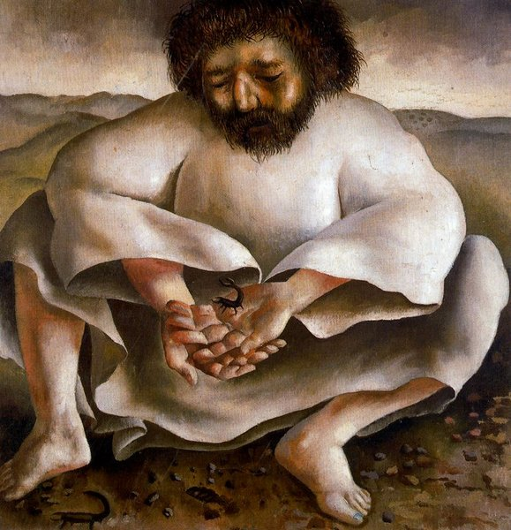
You could call our next picture an almost home-grown one. It was painted by the 20th century Buckinghamshire artist, Stanley Spencer. At a particular point in his life, when he himself needed reflection and re-grouping, Spencer started a series of Lent paintings, one for each day of Lent with the title “Christ in the wilderness”. In the event he had only completed eight of them. This one is called The Scorpion, which is the little creepy-crawly that Jesus cradles in his hands. Its size is no match for the bulky figure of Jesus, but it is known to have a pair of grasping claws and a threatening tail with lethal venom in it capable of killing a human being. The usual attitude towards scorpions is to avoid them, or tread them under foot. But in this picture Jesus picks it up (there are others visible around his feet) and befriends it. He doesn’t kill it, but faces it. Is the artist’s own experience valid for us too? Temptation is not to be ignored, run away from, or pretend it does not exist. It has to be faced with all the superior gifts of our Spirit-filled humanity and see it in its insignificant smallness, which has no real power over us.

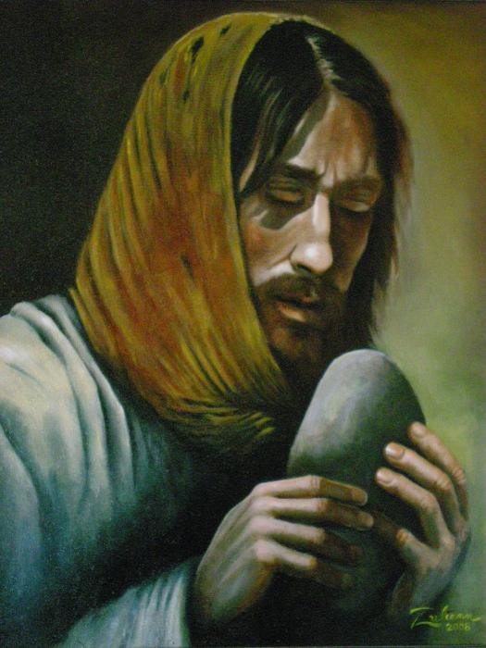
And here is our final picture, painted only a few years ago, which is the work of Rohann Zulienn, a contemporary American artist from West Virginia. There is no external Tempter included in this painting. Jesus is shown in the form of a gaunt-faced, hungry vagrant contemplating a bread-shaped stone. The temptation here comes from within. For this man of the road, it is eating to plug the hole of hunger, for us it may be something else, anything in fact, that we use to fill the empty space inside of us that belongs to God alone. When we feel the emptiness we think something is wrong and try to combat it with things like eating, shopping, blaming or taking care of other people. But any attempt is as futile as eating the piece of stone would be for this vagrant for his hunger. The space within is “the holy of holies, the uncluttered throne of the Lord our God”, to use Barbara Brown Taylor’s phrase, which “nothing on earth can fill”. (Barbara Brown Taylor: Home By Another Way, 1999) Would Lent be a good opportunity, I wonder, to find out what our own particular ‘stones’ are that we are trying to use for plugging the space within and leave them behind? What would it be like to live truly on God’s grace alone?

.

